**Assignment: Multiple Classes with Association**



Session: 2021 – 2024

**Submitted by:**

Abdul Mateen 2021-CS-190

**Supervised by:**

Dr. Maida Shahid

Department of Computer Science

**University of Engineering and Technology**

**Lahore Pakistan**

Table of Contents

UMAS 3

Case Study Scenario 3

Domain Model with only the Class names 3

Domain Model with Relations and Constraints 3

Domain Model with Multiplicity 3

Class Diagram 3

Full Code 3

OCEAN NAVIGATION 3

Case Study Scenario 3

Domain Model with only the Class names 3

Domain Model with Relations and Constraints 3

Domain Model with Multiplicity 3

Class Diagram 3

Full Code 3

POINT AND LINE 4

Case Study Scenario 4

Domain Model with only the Class names 4

Domain Model with Relations and Constraints 4

Domain Model with Multiplicity 4

Class Diagram 4

Full Code 4

POINT OF SALE 4

Case Study Scenario 4

Domain Model with only the Class names 4

Domain Model with Relations and Constraints 4

Domain Model with Multiplicity 4

Class Diagram 4

Full Code 4

TESLAS COFFE SHOP 4

Case Study Scenario 4

Domain Model with only the Class names 4

Domain Model with Relations and Constraints 4

Domain Model with Multiplicity 4

Class Diagram 4

Full Code 4

GAME OBJECT 4

Case Study Scenario 4

Domain Model with only the Class names 4

Domain Model with Relations and Constraints 4

Domain Model with Multiplicity 4

Class Diagram 4

Full Code 4

# **UMAS**

## **Case Study Scenario**

Academic branch offers different programs within different departments each Program has a degree title and duration of degree. Student Apply for admission in University and provides his/her name, age, FSC, and Ecat Marks and selects any number of preferences among the available programs. Admission department prepares a merit list according to the highest merit and Available seats and registers selected students in the program. Academic Branch also add subjects for each program. A subject have subject code, Credit hours, subject Type, and subject Fee a Program cannot have more than 20Credit hour subjects. A Student registers multiple subjects but only from his Enrolled program’s subject but he/she cannot take more than 9 credit hours. Fee department generate fees according to registered subjects of the students.

## **Domain Model with only the Class names**

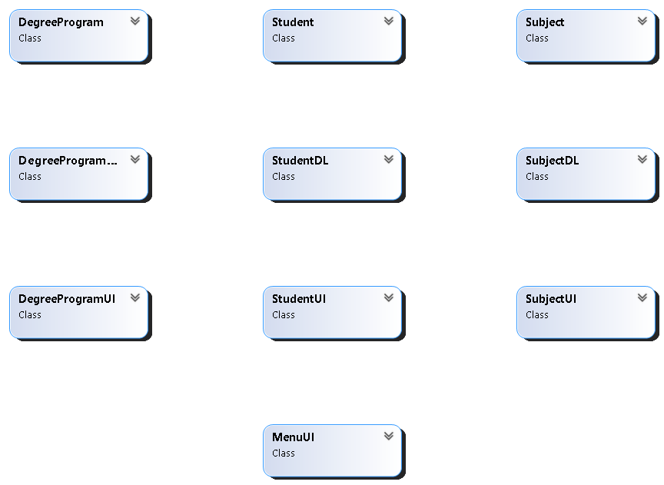

## **Domain Model with Relations and Constraints**

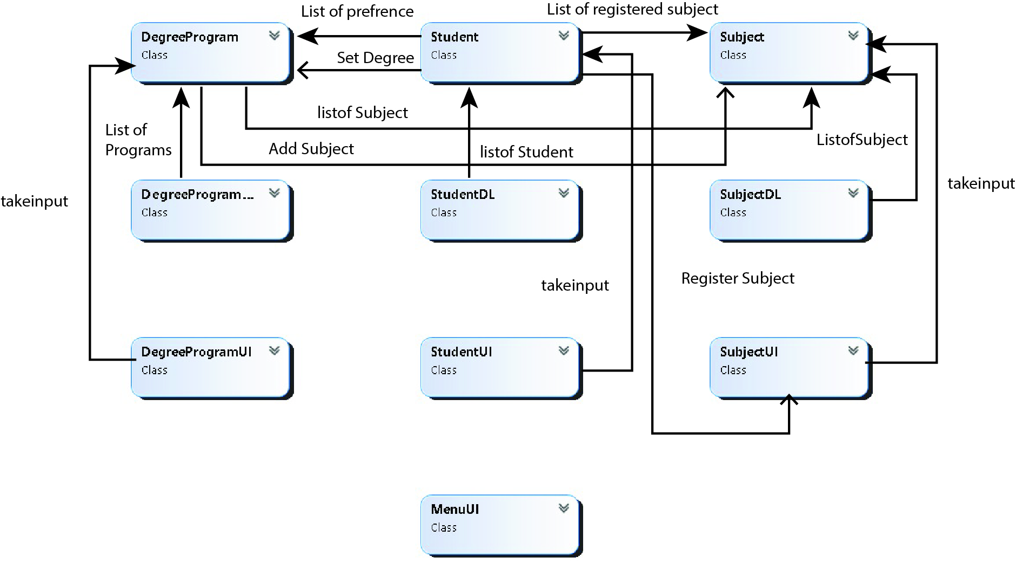

## **Class Diagram**

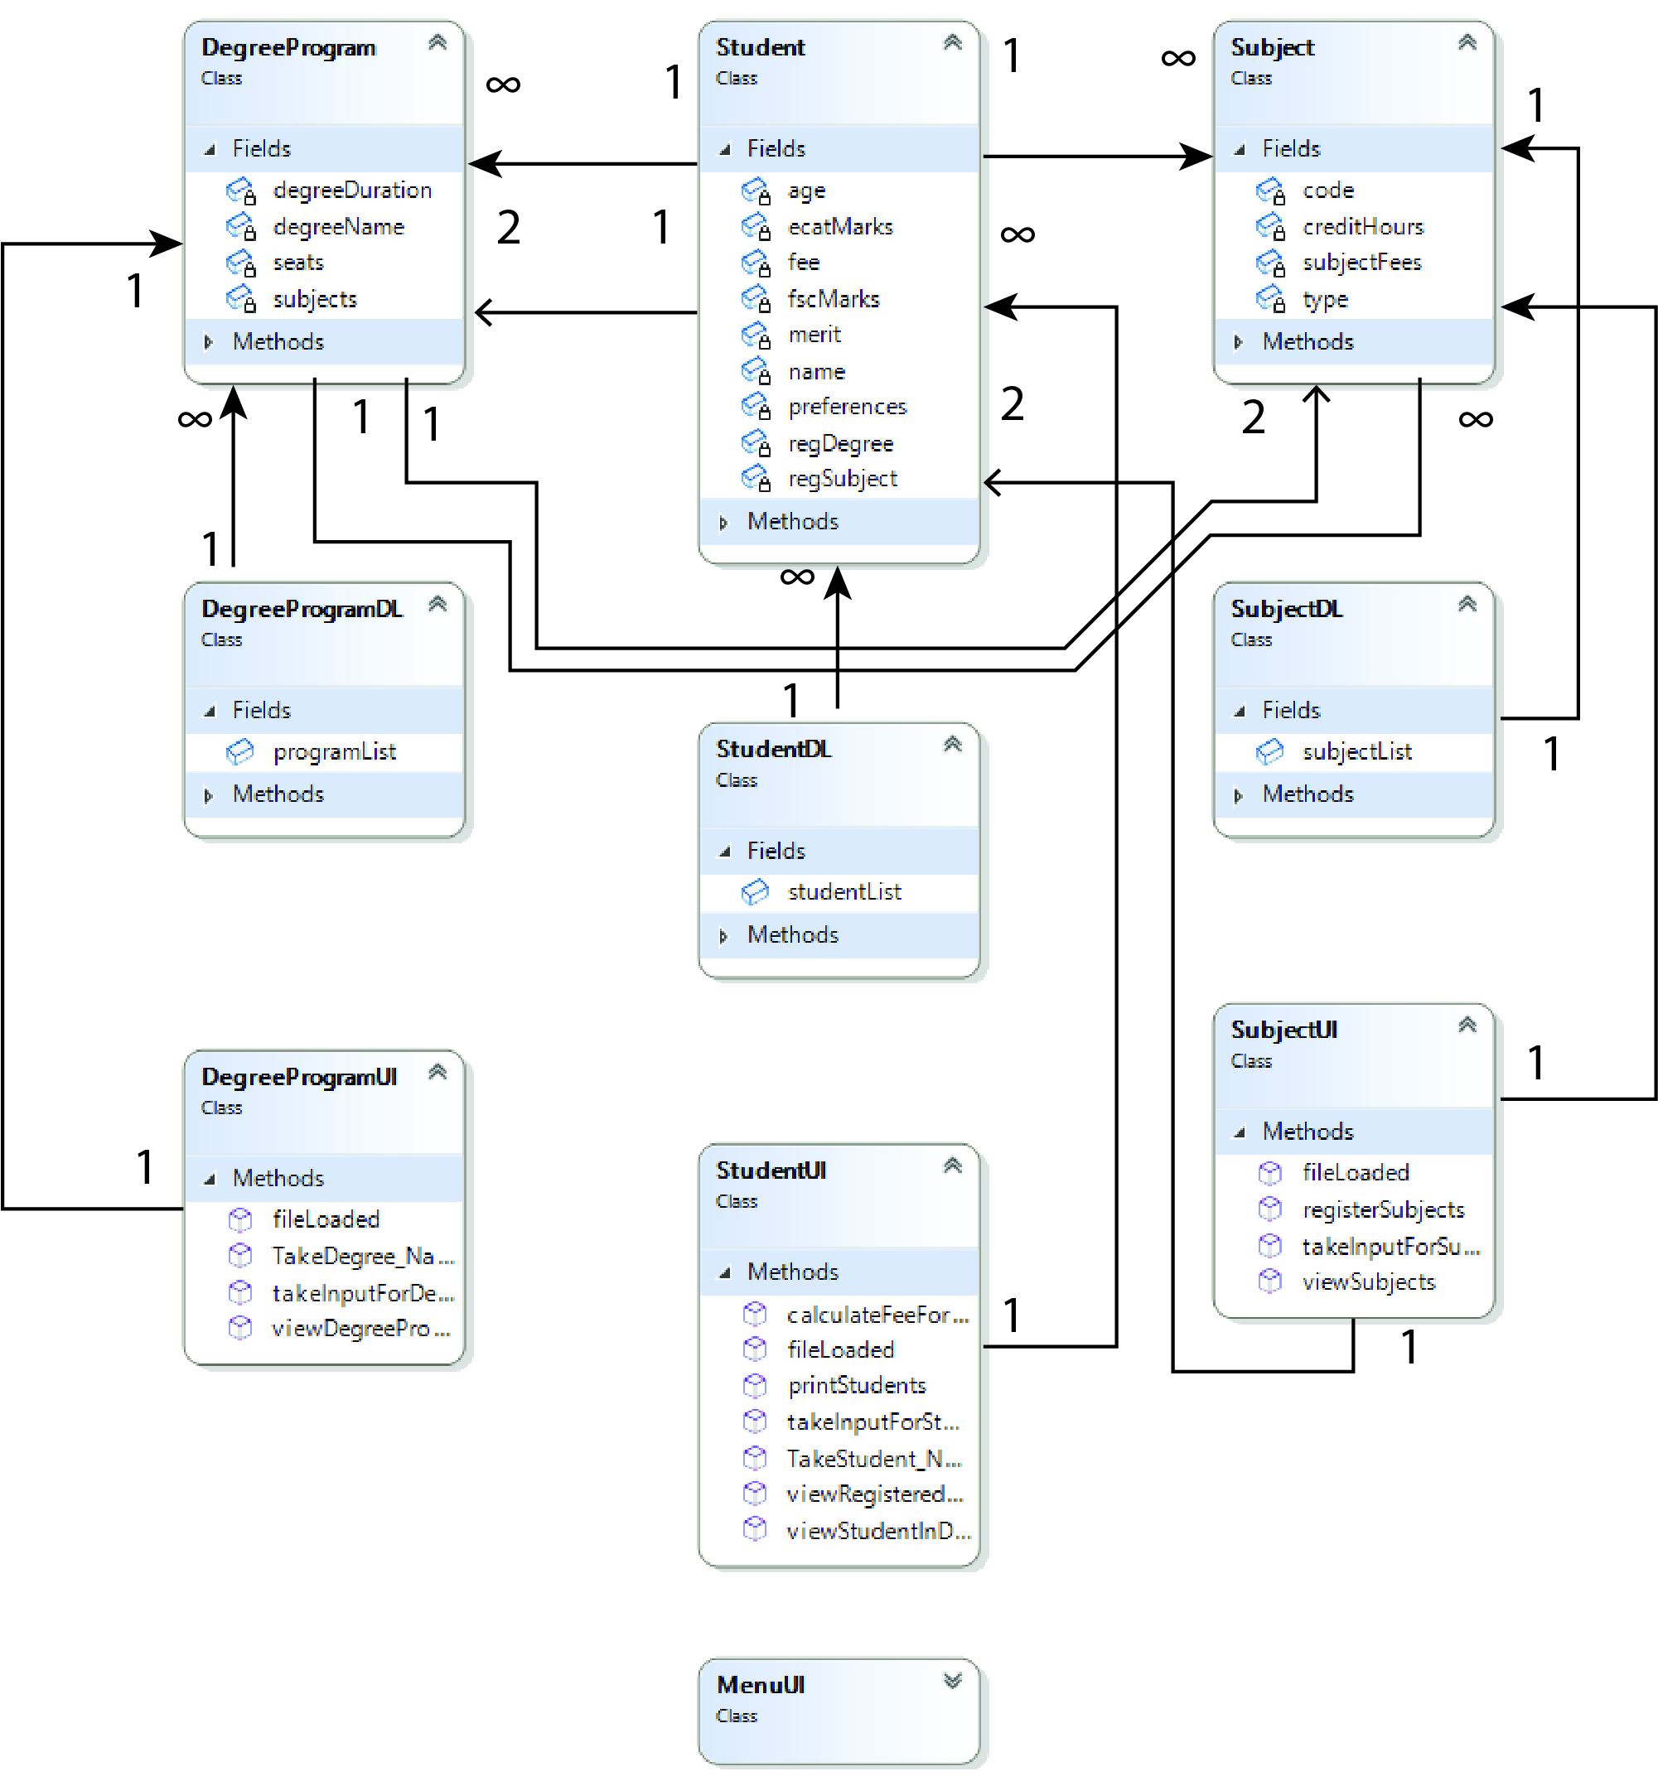

## **Full Code**

class DegreeProgram

{

private string degreeName;

private float degreeDuration;

private List<Subject> subjects;

private int seats;

public string getdegreeName()

{

return degreeName;

}

public float getdegreeDuration()

{

return degreeDuration;

}

public List<Subject> getsubjects()

{

return subjects;

}

public int getseats()

{

return seats;

}

public void setdegreeName(string degreeName)

{

this.degreeName=degreeName;

}

public void setdegreeDuration(int degreeDuration)

{

this.degreeDuration=degreeDuration;

}

public void setseats(int seats)

{

this.seats=seats;

}

public DegreeProgram(string degreeName, float degreeDuration, int seats)

{

this.degreeName = degreeName;

this.degreeDuration = degreeDuration;

this.seats = seats;

subjects = new List<Subject>();

}

public Subject isSubjectExists(Subject sub)

{

foreach (Subject s in subjects)

{

if (s.getcode()== sub.getcode())

{

return s;

}

}

return null;

}

public bool AddSubject(Subject s)

{

int creditHours = calculateCreditHours();

if(creditHours + s.getcreditHours()<= 20)

{

subjects.Add(s);

return true;

}

else

{

return false;

}

}

public int calculateCreditHours()

{

int count = 0;

for (int x = 0; x < subjects.Count; x++)

{

count = count + subjects[x].getcreditHours();

}

return count;

}

}

class Student

{

private string name;

private int age;

private double fscMarks;

private double ecatMarks;

private double merit;

private float fee;

private List<DegreeProgram> preferences;

private List<Subject> regSubject;

private DegreeProgram regDegree;

public string getname() { return name; }

public int getage() { return age; }

public double getfscMarks() { return fscMarks; }

public double getecatMarks() { return ecatMarks; }

public double getmerit() { return merit; }

public List<DegreeProgram> getpreferences() { return preferences; }

public List<Subject> getregSubject() { return regSubject; }

public DegreeProgram getregDegree() { return regDegree; }

public void setname(string name) { this.name=name; }

public void setage(int age) { this.age=age; }

public void setfscMarks(double fscMarks) { this.fscMarks=fscMarks; }

public void setecatMarks(double ecatMarks) { this.ecatMarks=ecatMarks; }

public void setmerit(double merit) { this.merit=merit; }

public void Addpreferences(DegreeProgram prefrences) { this.preferences.Add(prefrences); }

public void setregDegree(DegreeProgram regDegree) {this.regDegree=regDegree; }

public Student(string name, int age, double fscMarks, double ecatMarks, List<DegreeProgram> preferences)

{

this.name = name;

this.age = age;

this.fscMarks = fscMarks;

this.ecatMarks = ecatMarks;

this.preferences = preferences;

regSubject = new List<Subject>();

}

public void calculateMerit()

{

this.merit = (((fscMarks / 1100) * 0.45F) + ((ecatMarks / 400) * 0.55F)) * 100;

}

public bool regStudentSubject(Subject s)

{

int stCH = getCreditHours();

if (regDegree != null && stCH + s.getcreditHours()<= 9)

{

Subject sub=regDegree.isSubjectExists(s);

if (sub != null)

{

regSubject.Add(sub);

}

return true;

}

else

{

return false;

}

}

public int getCreditHours()

{

int count = 0;

foreach (Subject sub in regSubject)

{

count = count + sub.getcreditHours();

}

return count;

}

public float calculateFee()

{

float fee = 0;

if (regDegree != null)

{

foreach (Subject sub in regSubject)

{

fee = fee + sub.getsubjectFees();

}

}

this.fee = fee;

return fee;

}

}

class Subject

{

private string code;

private string type;

private int creditHours;

private int subjectFees;

public string getcode() { return code; }

public string gettype() { return type; }

public int getcreditHours() { return creditHours; }

public int getsubjectFees() { return subjectFees; }

public void setcode(string code) { this.code=code; }

public void settype(string type) { this.type=type; }

public void setcode(int creditHours) { this.creditHours=creditHours; }

public void setsubjectFees(int subjectFees) { this.subjectFees = subjectFees; }

public Subject(string code, string type, int creditHours, int subjectFees)

{

this.code = code;

this.type = type;

this.creditHours = creditHours;

this.subjectFees = subjectFees;

}

}

class DegreeProgramDL

{

public static List<DegreeProgram> programList = new List<DegreeProgram>();

public static void addIntoDegreeList(DegreeProgram d)

{

programList.Add(d);

}

public static DegreeProgram isDegreeExists(string degreeName)

{

foreach (DegreeProgram d in programList)

{

if (d.getdegreeName()== degreeName)

{

return d;

}

}

return null;

}

public static void storeintoFile(string path, DegreeProgram d)

{

StreamWriter f = new StreamWriter(path, true);

string SubjectNames = "";

for(int x = 0; x < d.getsubjects().Count - 1; x++)

{

SubjectNames = SubjectNames + d.getsubjects()[x].gettype()+ ";";

}

SubjectNames = SubjectNames + d.getsubjects()[d.getsubjects().Count - 1].gettype();

f.WriteLine(d.getdegreeName() + "," + d.getdegreeDuration()+ "," + d.getseats()+ "," + SubjectNames);

f.Flush();

f.Close();

}

public static bool readFromFile(string path)

{

StreamReader f = new StreamReader(path);

string record;

if (File.Exists(path))

{

while ((record = f.ReadLine()) != null)

{

string[] splittedRecord = record.Split(',');

string degreeName = splittedRecord[0];

float degreeDuration = float.Parse(splittedRecord[1]);

int seats = int.Parse(splittedRecord[2]);

string[] splittedRecordForSubject = splittedRecord[3].Split(';');

DegreeProgram d = new DegreeProgram(degreeName, degreeDuration, seats);

for (int x = 0; x < splittedRecordForSubject.Length; x++)

{

Subject s = SubjectDL.isSubjectExists(splittedRecordForSubject[x]);

if (s != null)

{

d.AddSubject(s);

}

}

addIntoDegreeList(d);

}

f.Close();

return true;

}

else

{

return false;

}

}

}

class StudentDL

{

public static List<Student> studentList = new List<Student>();

public static void addIntoStudentList(Student s)

{

studentList.Add(s);

}

public static Student StudentPresent(string name)

{

foreach (Student s in studentList)

{

if (name == s.getname()&& s.getregDegree()!= null)

{

return s;

}

}

return null;

}

public static List<Student> sortStudentsByMerit()

{

List<Student> sortedStudentList = new List<Student>();

foreach (Student s in studentList)

{

s.calculateMerit();

}

sortedStudentList = studentList.OrderByDescending(o => o.getmerit()).ToList();

return sortedStudentList;

}

public static void giveAdmission(List<Student> sortedStudentList)

{

foreach (Student s in sortedStudentList)

{

foreach (DegreeProgram d in s.getpreferences())

{

if (d.getseats()> 0 && s.getregDegree()== null)

{

s.setregDegree(d);

d.setseats(d.getseats()-1);

break;

}

}

}

}

public static void storeintoFile(string path, Student s)

{

StreamWriter f = new StreamWriter(path, true);

string degreeNames = "";

for(int x = 0; x < s.getpreferences().Count - 1; x++)

{

degreeNames = degreeNames + s.getpreferences()[x].getdegreeName()+ ";";

}

degreeNames = degreeNames + s.getpreferences()[s.getpreferences().Count - 1].getdegreeName();

f.WriteLine(s.getname()+ "," + s.getage()+ "," + s.getfscMarks()+ "," + s.getecatMarks()+ "," + degreeNames);

f.Flush();

f.Close();

}

public static bool readFromFile(string path)

{

StreamReader f = new StreamReader(path);

string record;

if (File.Exists(path))

{

while ((record = f.ReadLine()) != null)

{

string[] splittedRecord = record.Split(',');

string name = splittedRecord[0];

int age = int.Parse(splittedRecord[1]);

double fscMarks = double.Parse(splittedRecord[2]);

double ecatMarks = double.Parse(splittedRecord[3]);

string[] splittedRecordForPreference = splittedRecord[4].Split(';');

List<DegreeProgram> preferences = new List<DegreeProgram>();

for (int x = 0; x < splittedRecordForPreference.Length; x++)

{

DegreeProgram d = DegreeProgramDL.isDegreeExists(splittedRecordForPreference[x]);

if (d != null)

{

if (!(preferences.Contains(d)))

{

preferences.Add(d);

}

}

}

Student s = new Student(name, age, fscMarks, ecatMarks, preferences);

studentList.Add(s);

}

f.Close();

return true;

}

else

{

return false;

}

}

}

class SubjectDL

{

public static List<Subject> subjectList = new List<Subject>();

public static void addSubjectIntoList(Subject s)

{

subjectList.Add(s);

}

public static bool readFromFile(string path)

{

StreamReader f = new StreamReader(path);

string record;

if (File.Exists(path))

{

while ((record = f.ReadLine()) != null)

{

string[] splittedRecord = record.Split(',');

string code = splittedRecord[0];

string type = splittedRecord[1];

int creditHours = int.Parse(splittedRecord[2]);

int subjectFees = int.Parse(splittedRecord[3]);

Subject s = new Subject(code, type, creditHours, subjectFees);

addSubjectIntoList(s);

}

f.Close();

return true;

}

else

{

return false;

}

}

public static void storeintoFile(string path, Subject s)

{

StreamWriter f = new StreamWriter(path, true);

f.WriteLine(s.getcode()+ "," + s.gettype()+ "," + s.getcreditHours()+ "," + s.getsubjectFees());

f.Flush();

f.Close();

}

public static Subject isSubjectExists(string type)

{

foreach (Subject s in subjectList)

{

if (s.gettype()== type)

{

return s;

}

}

return null;

}

}

class DegreeProgramUI

{

public static DegreeProgram takeInputForDegree()

{

string degreeName;

float degreeDuration;

int seats;

Console.Write("Enter Degree Name: ");

degreeName = Console.ReadLine();

Console.Write("Enter Degree Duration: ");

degreeDuration = float.Parse(Console.ReadLine());

Console.Write("Enter Seats for Degree: ");

seats = int.Parse(Console.ReadLine());

DegreeProgram degProg = new DegreeProgram(degreeName, degreeDuration, seats);

Console.Write("Enter How many Subjects to Enter: ");

int count = int.Parse(Console.ReadLine());

for (int x = 0; x < count; x++)

{

Subject s = SubjectUI.takeInputForSubject();

if (degProg.AddSubject(s))

{

// These are done here because we did not add a separate option to add only the Subjects.

if (!(SubjectDL.subjectList.Contains(s)))

{

SubjectDL.addSubjectIntoList(s);

SubjectDL.storeintoFile("subject.txt", s);

}

Console.WriteLine("Subject Added");

}

else

{

Console.WriteLine("Subject Not Added");

Console.WriteLine("20 credit hour limit exceeded");

x--;

}

}

return degProg;

}

public static void viewDegreePrograms()

{

foreach (DegreeProgram dp in DegreeProgramDL.programList)

{

Console.WriteLine(dp.getdegreeName());

}

}

public static void fileLoaded()

{

Console.WriteLine("DegreeProgram Data Loaded Successfully");

}

public static string TakeDegree_Name()

{

Console.Write("Enter Degree Name: ");

string degName = Console.ReadLine();

return degName;

}

}

class MenuUI

{

public static void header()

{

Console.WriteLine("*****************************************");

Console.WriteLine(" UAMS ");

Console.WriteLine("*****************************************");

}

public static void clearScreen()

{

Console.WriteLine("Press any key to Continue..");

Console.ReadKey();

Console.Clear();

}

public static int Menu()

{

header();

int option;

Console.WriteLine("1. Add Student");

Console.WriteLine("2. Add Degree Program");

Console.WriteLine("3. Generate Merit");

Console.WriteLine("4. View Registered Students");

Console.WriteLine("5. View Students of a Specific Program");

Console.WriteLine("6. Register Subjects for a Specific Student");

Console.WriteLine("7. Calculate Fees for all Registered Students");

Console.WriteLine("8. Exit");

Console.Write("Enter Option: ");

option = int.Parse(Console.ReadLine());

return option;

}

}

class StudentUI

{

public static void printStudents()

{

foreach (Student s in StudentDL.studentList)

{

if (s.getregDegree()!= null)

{

Console.WriteLine(s.getname()+ " got Admission in " + s.getregDegree().getdegreeName());

}

else

{

Console.WriteLine(s.getname()+ " did not get Admission");

}

}

}

public static void viewStudentInDegree(string degName)

{

Console.WriteLine("Name\tFSC\tEcat\tAge");

foreach (Student s in StudentDL.studentList)

{

if (s.getregDegree()!= null)

{

if (degName == s.getregDegree().getdegreeName())

{

Console.WriteLine(s.getname()+ "\t" + s.getfscMarks()+ "\t" + s.getecatMarks()+ "\t" + s.getage());

}

}

}

}

public static void viewRegisteredStudents()

{

Console.WriteLine("Name\tFSC\tEcat\tAge");

foreach (Student s in StudentDL.studentList)

{

if (s.getregDegree()!= null)

{

Console.WriteLine(s.getname()+ "\t" + s.getfscMarks()+ "\t" + s.getecatMarks()+ "\t" + s.getage());

}

}

}

public static Student takeInputForStudent()

{

string name;

int age;

double fscMarks;

double ecatMarks;

List<DegreeProgram> preferences = new List<DegreeProgram>();

Console.Write("Enter Student Name: ");

name = Console.ReadLine();

Console.Write("Enter Student Age: ");

age = int.Parse(Console.ReadLine());

Console.Write("Enter Student FSc Marks: ");

fscMarks = double.Parse(Console.ReadLine());

Console.Write("Enter Student Ecat Marks: ");

ecatMarks = double.Parse(Console.ReadLine());

Console.WriteLine("Available Degree Programs");

DegreeProgramUI.viewDegreePrograms();

Console.Write("Enter how many preferences to Enter: ");

int Count = int.Parse(Console.ReadLine());

for (int x = 0; x < Count; x++)

{

string degName = Console.ReadLine();

bool flag = false;

foreach (DegreeProgram dp in DegreeProgramDL.programList)

{

if (degName == dp.getdegreeName()&& !(preferences.Contains(dp)))

{

preferences.Add(dp);

flag = true;

}

}

if (flag == false)

{

Console.WriteLine("Enter Valid Degree Program Name");

x--;

}

}

Student s = new Student(name, age, fscMarks, ecatMarks, preferences);

return s;

}

public static void calculateFeeForAll()

{

foreach (Student s in StudentDL.studentList)

{

if (s.getregDegree()!= null)

{

Console.WriteLine(s.getname()+ " has " + s.calculateFee() + " fees");

}

}

}

public static void fileLoaded()

{

Console.WriteLine("Student Data Loaded Successfully");

}

public static string TakeStudent_Name()

{

Console.Write("Enter the Student Name: ");

string name = Console.ReadLine();

return name;

}

}

class SubjectUI

{

public static Subject takeInputForSubject()

{

string code;

string type;

int creditHours;

int subjectFees;

Console.Write("Enter Subject Code: ");

code = Console.ReadLine();

Console.Write("Enter Subject Type: ");

type = Console.ReadLine();

Console.Write("Enter Subject Credit Hours: ");

creditHours = int.Parse(Console.ReadLine());

Console.Write("Enter Subject Fees: ");

subjectFees = int.Parse(Console.ReadLine());

Subject sub = new Subject(code, type, creditHours, subjectFees);

return sub;

}

public static void viewSubjects(Student s)

{

if (s.getregDegree()!= null)

{

Console.WriteLine("Sub Code\tSub Type");

foreach (Subject sub in s.getregDegree().getsubjects())

{

Console.WriteLine(sub.getcode()+ "\t\t" + sub.gettype());

}

}

}

public static void registerSubjects(Student s)

{

Console.WriteLine("Enter how many subjects you want to register");

int count = int.Parse(Console.ReadLine());

for (int x = 0; x < count; x++)

{

Console.WriteLine("Enter the subject Code");

string code = Console.ReadLine();

bool Flag = false;

foreach (Subject sub in s.getregDegree().getsubjects())

{

if (code == sub.getcode()&& !(s.getregSubject().Contains(sub)))

{

if (s.regStudentSubject(sub))

{

Flag = true;

break;

}

else

{

Console.WriteLine("A student cannot have more than 9 CH");

Flag = true;

break;

}

}

}

if (Flag == false)

{

Console.WriteLine("Enter Valid Course");

x--;

}

}

}

public static void fileLoaded()

{

Console.WriteLine("Subject Data Loaded Successfully");

}

}

static void Main(string[] args)

{

string subjectPath = "subject.txt";

string degreePath = "degree.txt";

string studentPath = "student.txt";

if (SubjectDL.readFromFile(subjectPath))

{

SubjectUI.fileLoaded();

}

if (DegreeProgramDL.readFromFile(degreePath))

{

DegreeProgramUI.fileLoaded();

}

if (StudentDL.readFromFile(studentPath))

{

StudentUI.fileLoaded();

}

int option;

do

{

option = MenuUI.Menu();

MenuUI.clearScreen();

if (option == 1)

{

if (DegreeProgramDL.programList.Count > 0)

{

Student s = StudentUI.takeInputForStudent();

StudentDL.addIntoStudentList(s);

StudentDL.storeintoFile(studentPath, s);

}

}

else if (option == 2)

{

DegreeProgram d = DegreeProgramUI.takeInputForDegree();

DegreeProgramDL.addIntoDegreeList(d);

DegreeProgramDL.storeintoFile(degreePath, d);

}

else if (option == 3)

{

List<Student> sortedStudentList = new List<Student>();

sortedStudentList = StudentDL.sortStudentsByMerit();

StudentDL.giveAdmission(sortedStudentList);

StudentUI.printStudents();

}

else if (option == 4)

{

StudentUI.viewRegisteredStudents();

}

else if (option == 5)

{

string degName=DegreeProgramUI.TakeDegree_Name();

StudentUI.viewStudentInDegree(degName);

}

else if (option == 6)

{

string name = StudentUI.TakeStudent_Name();

Student s = StudentDL.StudentPresent(name);

if (s != null)

{

SubjectUI.viewSubjects(s);

SubjectUI.registerSubjects(s);

}

}

else if (option == 7)

{

StudentUI.calculateFeeForAll();

}

MenuUI.clearScreen();

}

while (option != 8);

}

## **Sequence Diagrams**

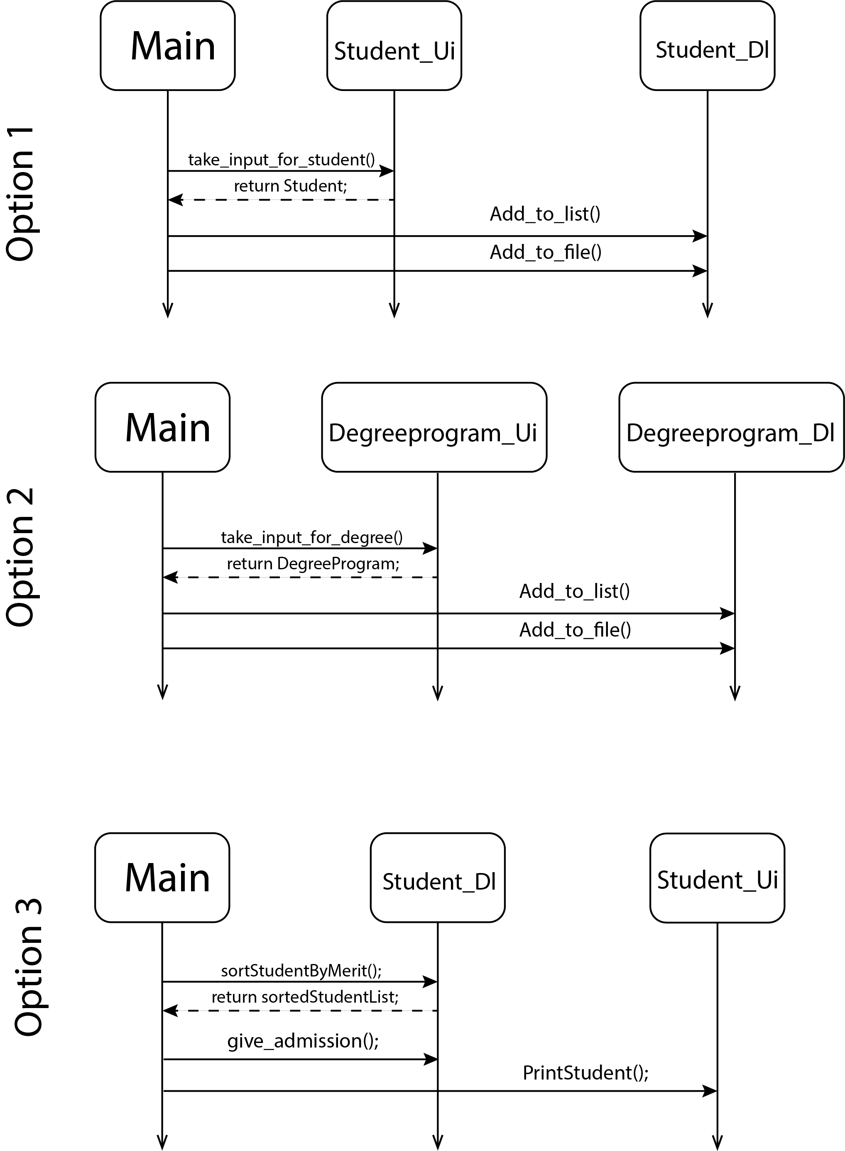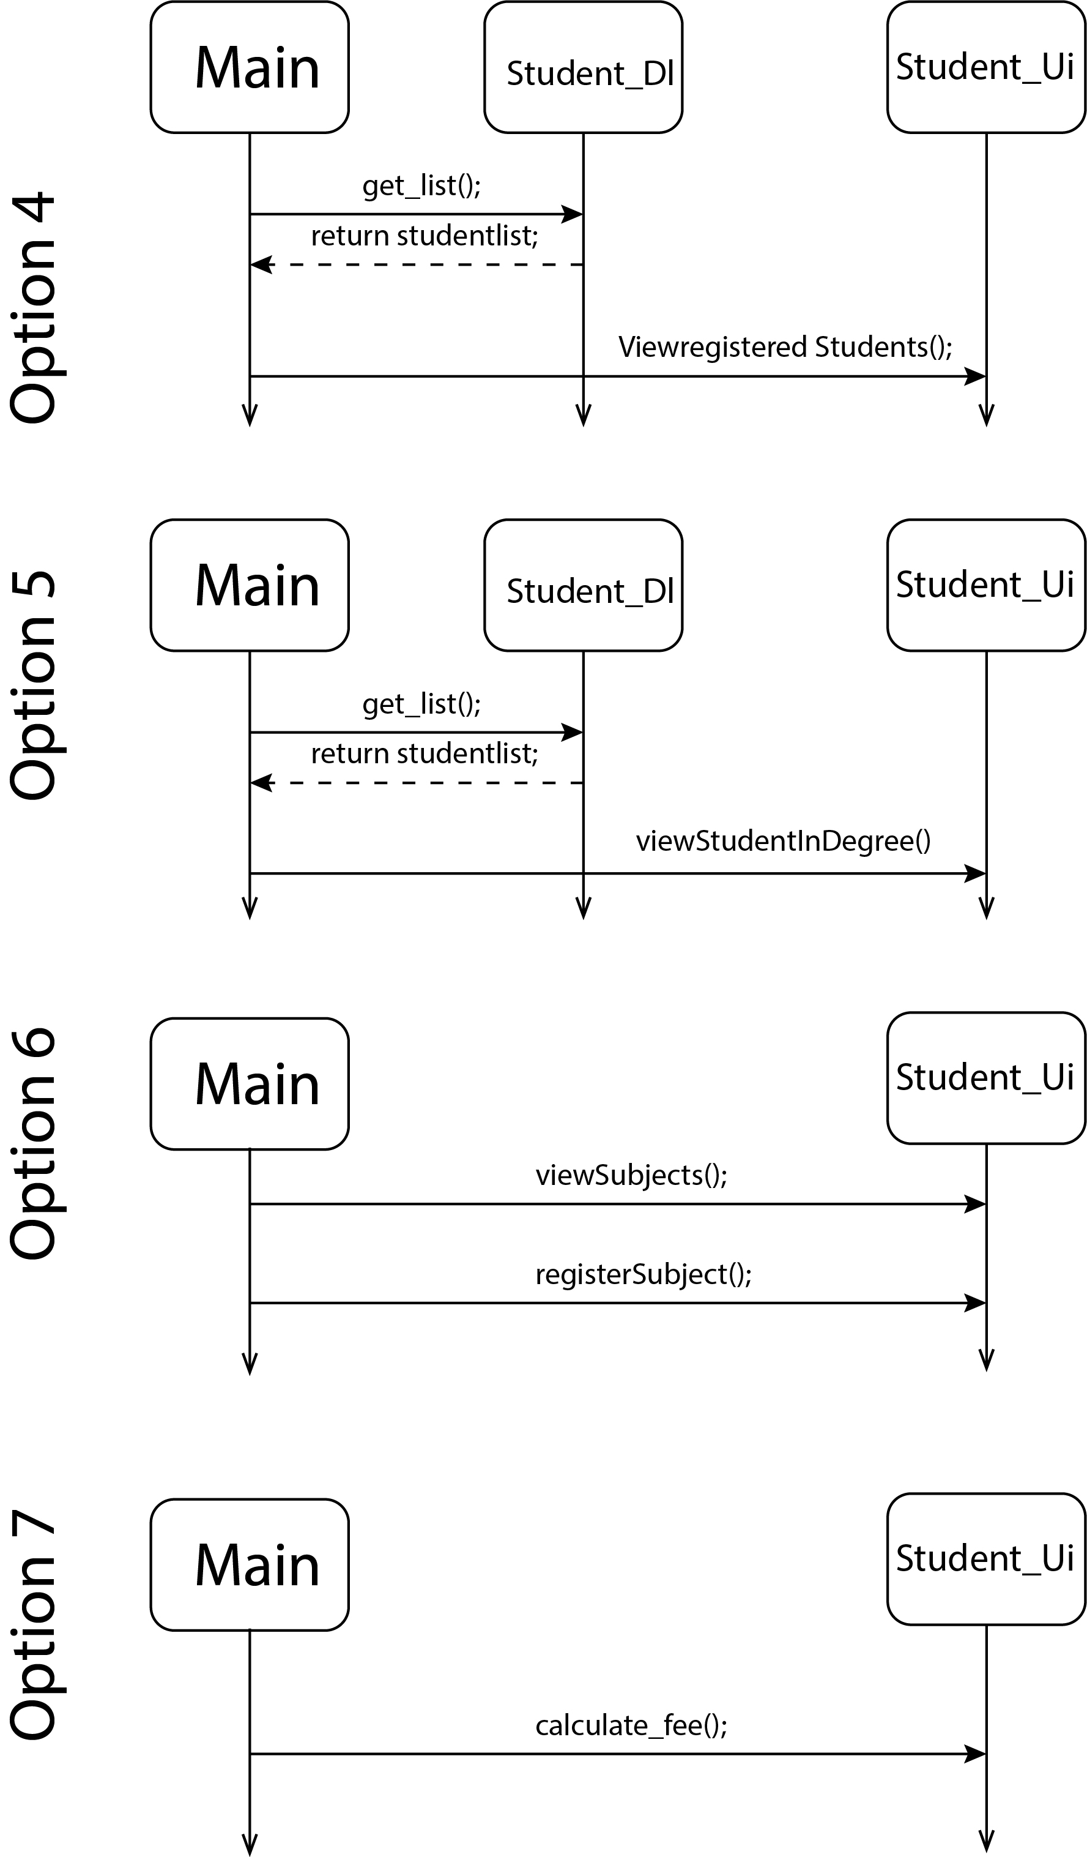

# **OCEAN NAVIGATION**

## **Case Study Scenario**

In ocean navigation, locations are measured in degrees and minutes of latitude and longitude. Thus ifyou’re lying off the mouth of Papeete Harbor in Tahiti, your location is 149 degrees 34.8 minutes westlongitude, and 17 degrees 31.5 minutes south latitude. This is written as 149°34.8’ W, 17°31.5’ S. Thereare 60 minutes in a degree. (An older system also divided a minute into 60 seconds, but the modernapproach is to use decimal minutes instead.) Longitude is measured from 0 to 180 degrees, east or westfrom Greenwich, England, to the international dateline in the Pacific. Latitude is measured from 0 to 90degrees, north or south from the equator to the poles.

Create a class angle that includes three member variables: an int for degrees, a float for minutes, and achar for the direction letter (N, S, E, or W). This class can hold either a latitude variable or a longitudevariable.Write one member function to change the angle value (in degrees and minutes) and a direction givenfrom the user, and a second to display the angle value in 179°59.9’ E in string format. Also write athree-argument constructor.

Create a class called ship that incorporates a ship’s number and location. Use two variables of the angleclass to represent the ship’s latitude and longitude for the ship’s location. Write a parameterizedconstructor to initialize the attributes of the ship class. A member function of the ship class should printthe position (latitude and longitude) of the ship; another should report/print the serial number.

## **Domain Model with only the Class names**

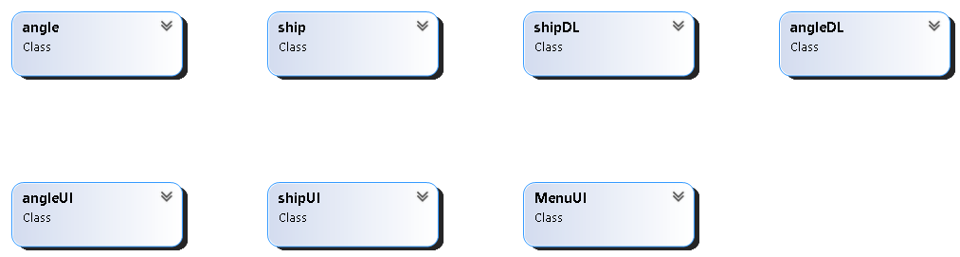

## **Domain Model with Relations and Constraints**

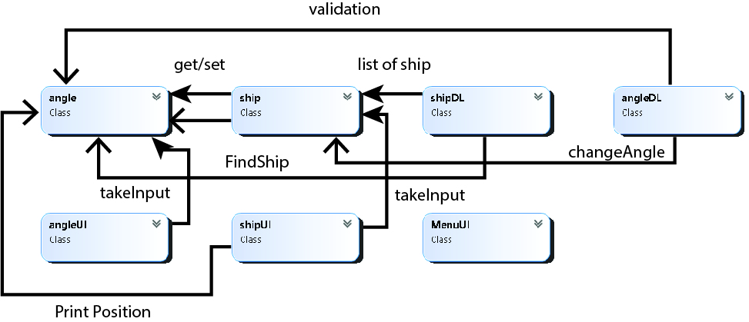

## **Class Diagram**

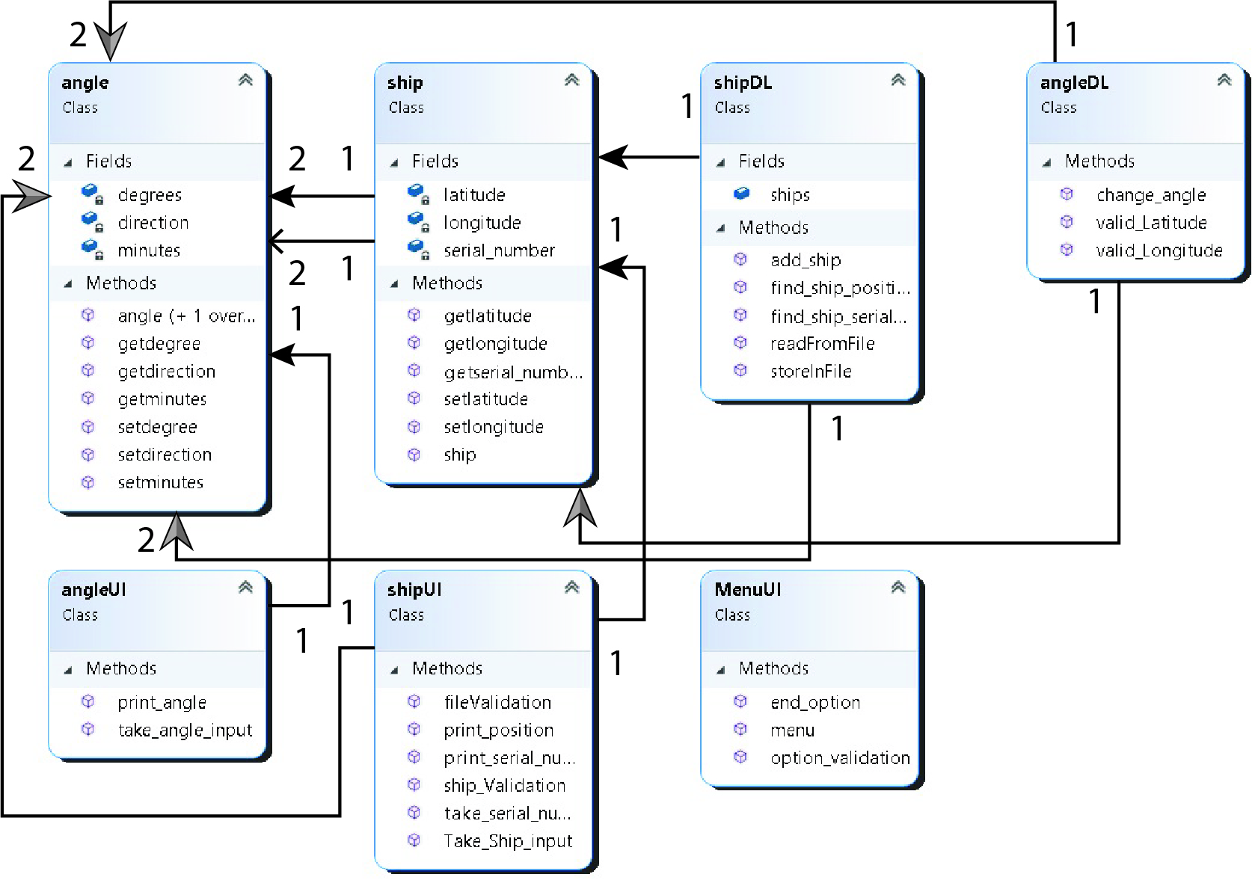

## **Full Code**

internal class Angle

{

private int degree;

private float minutes;

private char direction;

public int Degree

{

get { return degree; }

set { degree = value; }

}

public float Minutes

{

get { return minutes; }

set { minutes = value; }

}

public char Direction

{

get { return this.direction; }

set { this.direction = value; }

}

}

internal class Ship

{

private string name;

private Angle X;

private Angle Y;

public Ship() { }

public Ship(string name, Angle x, Angle y)

{

this.name = name;

X = x;

Y = y;

}

public string Name

{

get { return name; }

set { name = value; }

}

public Angle x

{

get { return X; }

set { X = value; }

}

public Angle y

{

get { return Y; }

set { Y = value; }

}

public void replace(Angle x, Angle y)

{

this.X=x;

this.Y=y;

}

}

internal class Crud

{

public static List<Ship> ship_list = new List<Ship>();

public static Ship index(string name)

{

for (int i = 0; i < ship_list.Count; i++)

{

if (name == ship_list[i].Name)

{

return ship_list[i];

}

}

return null;

}

public static Ship check_ship(Angle x,Angle y)

{

for (int i = 0; i < ship_list.Count; i++)

{

if (x.Degree == ship_list[i].x.Degree && y.Degree==ship_list[i].y.Degree && x.Minutes == ship_list[i].x.Minutes && y.Minutes == ship_list[i].y.Minutes && x.Direction == ship_list[i].x.Direction && y.Direction == ship_list[i].y.Direction)

{

return ship_list[i];

}

}

return null;

}

public static void add_ship(Ship input)

{

ship_list.Add(input);

}

}

internal class Menu_Ui

{

public static char menu()

{

Console.WriteLine("1) Add Ship");

Console.WriteLine("2) View Ship Position");

Console.WriteLine("3) View Ship Serial Number");

Console.WriteLine("4) Change Ship Position");

Console.WriteLine("5) Exit");

char ch = Console.ReadLine()[0];

return ch;

}

}

internal class Ship_Ui

{

public static Ship take_input()

{

Angle input = new Angle();

Angle input2 = new Angle();

Console.WriteLine("Enter the Name : ");

string name = Console.ReadLine();

Console.WriteLine("Enter the X Degree : ");

input.Degree =int.Parse(Console.ReadLine());

Console.WriteLine("Enter the X Minute : ");

input.Minutes = float.Parse(Console.ReadLine());

Console.WriteLine("Enter the X Direction : ");

input.Direction = Console.ReadLine()[0];

Console.WriteLine("Enter the Y Degree : ");

input2.Degree = int.Parse(Console.ReadLine());

Console.WriteLine("Enter the Y Minute : ");

input2.Minutes = float.Parse(Console.ReadLine());

Console.WriteLine("Enter the Y Direction : ");

input2.Direction = Console.ReadLine()[0];

Ship ship = new Ship(name, input, input2);

return ship;

}

public static void position()

{

Console.WriteLine("Enter the Name of ship : ");

string name = Console.ReadLine();

Ship output = Crud.index(name);

if (output == null)

{

Console.WriteLine("There is no such Ship.");

}

else

{

display_angle(output);

}

}

public static void serial_num()

{

Angle input = new Angle();

Angle input2 = new Angle();

Console.WriteLine("Enter the X Degree : ");

input.Degree = int.Parse(Console.ReadLine());

Console.WriteLine("Enter the X Minute : ");

input.Minutes = float.Parse(Console.ReadLine());

Console.WriteLine("Enter the X Direction : ");

input.Direction = Console.ReadLine()[0];

Console.WriteLine("Enter the Y Degree : ");

input2.Degree = int.Parse(Console.ReadLine());

Console.WriteLine("Enter the Y Minute : ");

input2.Minutes = float.Parse(Console.ReadLine());

Console.WriteLine("Enter the Y Direction : ");

input2.Direction = Console.ReadLine()[0];

Ship output = Crud.check_ship(input,input2);

if(output != null)

{

display_name(output);

}

else

{

Console.WriteLine("There is no such ship.");

}

}

public static void change_position()

{

Console.WriteLine("Enter the Name : ");

string name = Console.ReadLine();

Ship output = Crud.index(name);

if (output == null)

{

Console.WriteLine("There is no such Ship.");

}

else

{

Angle input = new Angle();

Angle input2 = new Angle();

Console.WriteLine("Enter the X Degree : ");

input.Degree = int.Parse(Console.ReadLine());

Console.WriteLine("Enter the X Minute : ");

input.Minutes = float.Parse(Console.ReadLine());

Console.WriteLine("Enter the X Direction : ");

input.Direction = Console.ReadLine()[0];

Console.WriteLine("Enter the Y Degree : ");

input2.Degree = int.Parse(Console.ReadLine());

Console.WriteLine("Enter the Y Minute : ");

input2.Minutes = float.Parse(Console.ReadLine());

Console.WriteLine("Enter the Y Direction : ");

input2.Direction = Console.ReadLine()[0];

output.replace(input, input2);

Console.WriteLine("Postion has been changed .");

}

}

public static void display_angle(Ship output)

{

Console.WriteLine("Ship is at " + output.x.Degree + "\u00b0" + output.x.Minutes + "'" + output.x.Direction + " and " + output.y.Degree + "\u00b0" + output.y.Minutes + "'" + output.y.Direction);

}

public static void display_name(Ship output)

{

Console.WriteLine("THe name of the ship is " + output.Name + " .");

}

}

static void Main(string[] args)

{

char op;

while(true)

{

op = Menu_Ui.menu();

Console.Clear();

if(op =='1')

{

Ship output = Ship_Ui.take_input();

Crud.add_ship(output);

}

else if(op =='2')

{

Ship_Ui.position();

}

else if(op=='3')

{

Ship_Ui.serial_num();

}

else if(op=='4')

{

Ship_Ui.change_position();

}

else if(op=='5')

{

break;

}

}

}

## **Sequence Diagram**

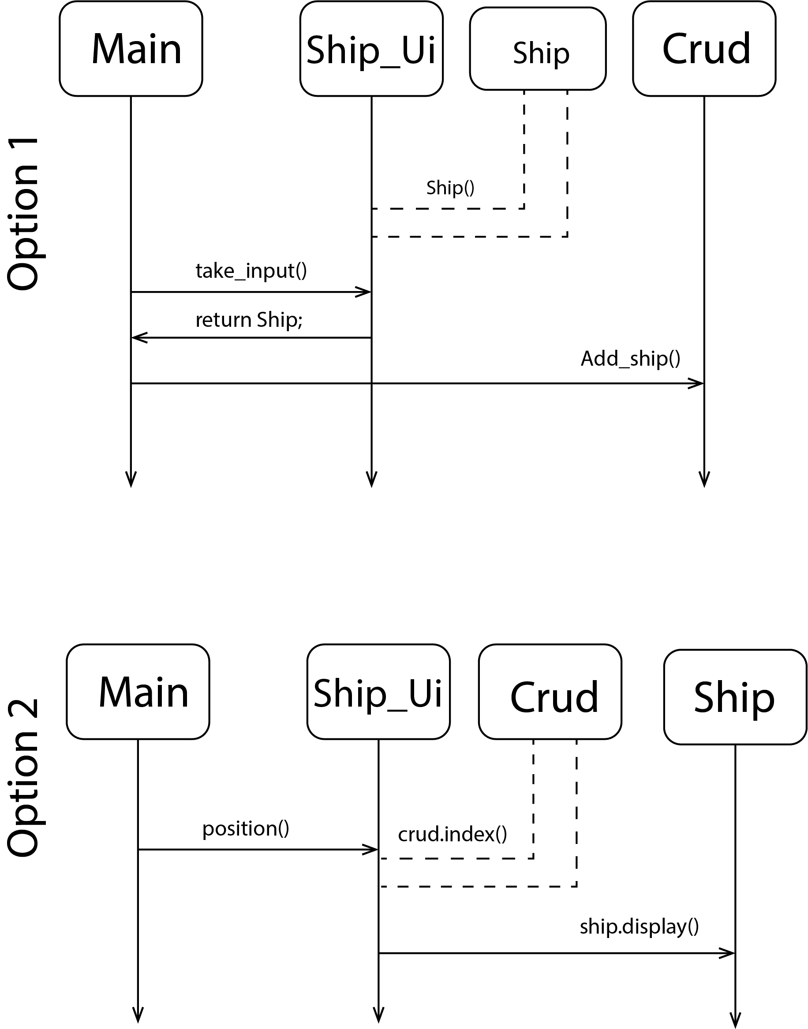

# **C:\Users\Abdul Mateen\AppData\Local\Microsoft\Windows\INetCache\Content.Word\sq34.jpg**

# **POINT AND LINE**

## **Case Study Scenario**

A class called MyPoint, which models a 2D point with x and y coordinates, is designed

as shown in the class diagram.

It contains

● Two instance variables x (int) and y (int).

● A default (or "no-argument" or "no-arg") constructor that constructs a point at the

default location of (0, 0).

● A parameterized constructor that constructs a point with the given x and y

coordinates.

● Getter and setter for the instance variables x and y.

● A method setXY() to set both x and y.

● A method called distanceWithCords(int x, int y) that returns the distance from this

point to another point at the given (x, y) coordinates.

● A method distanceWithObject(MyPoint another) that returns the distance from this

point to the given MyPoint instance (called another).

● Another method distanceFromZero() method that returns the distance from this

point to the origin (0,0)

A class called MyLine, which models a line with a begin point at (x1, y1) and an end

point at (x2, y2), is designed as shown in the class diagram. The MyLine class uses two

MyPoint instances (written in the earlier exercise) as its begin and end points. Write the

MyLine class. Also write a test driver to test all the public methods in the MyLine class.

Use distance formula to calculate the length of the line

## **Domain Model with only the Class names**

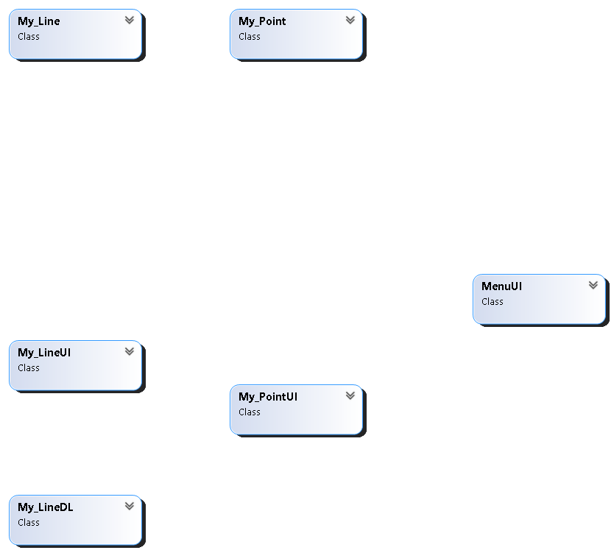

## **Domain Model with Relations and Constraints**

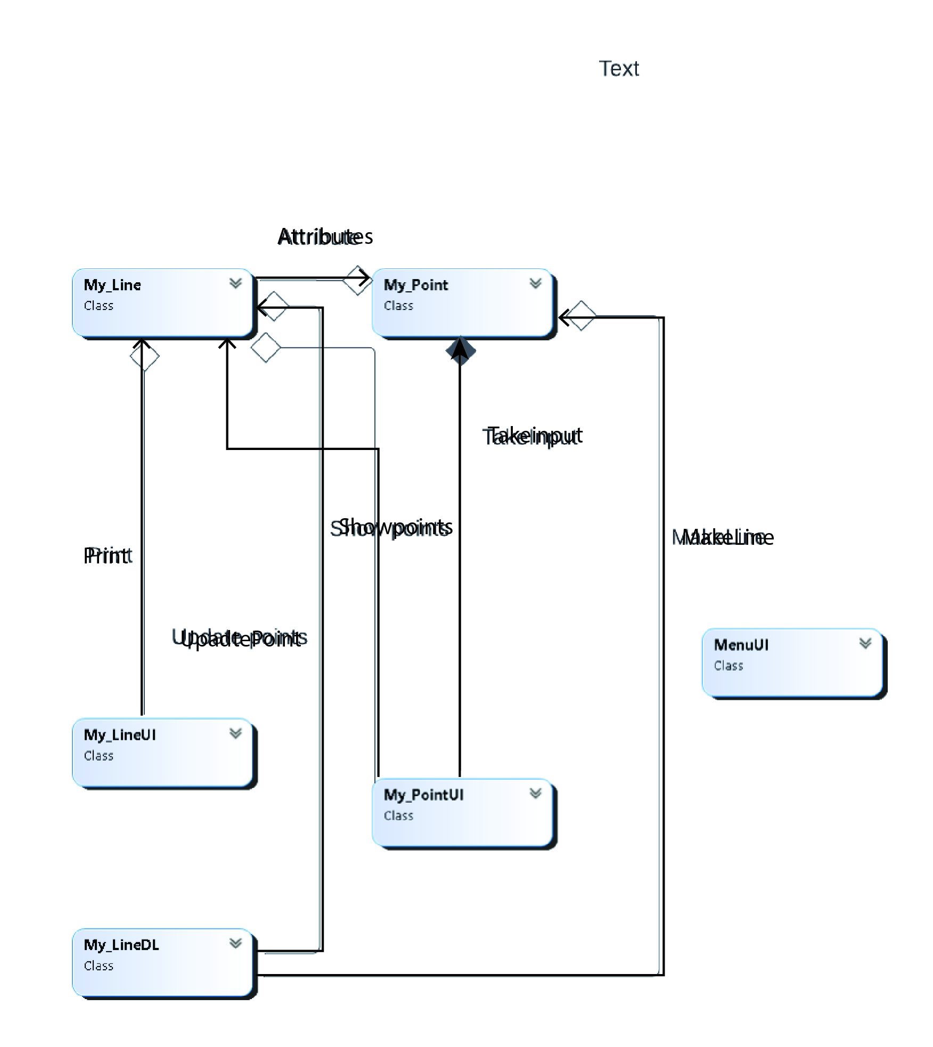

## **Class Diagram**

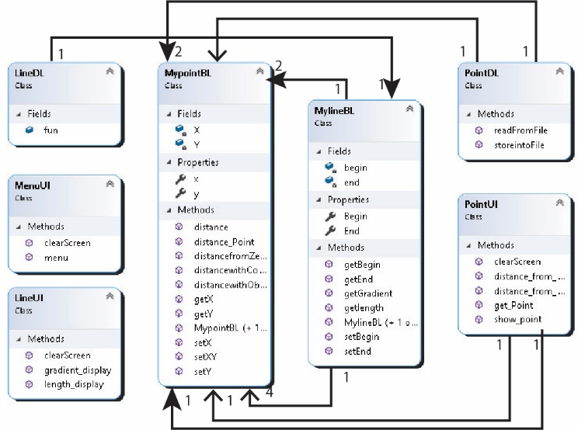

## **Full Code**

internal class line

{

private point P1=new point();

private point P2=new point();

public line() { }

public line(point p1,point p2)

{

this.P1=p1;

this.P2=p2;

}

public void set_start(point p1)

{

this.P1 = p1;

}

public void set_end(point p2)

{

this.P2= p2;

}

public point get_start()

{

return P1;

}

public point get_end()

{

return P2;

}

public double get_length()

{

return P1.distance_point(P2);

}

public double gradiant()

{

return (P2.getY() - P1.getY()) / (P2.getX() - P1.getX());

}

}

internal class point

{

private int X;

private int Y;

public point() { }

public point(int X,int Y)

{

this.X = X;

this.Y = Y;

}

public int getX()

{

return X;

}

public int getY()

{

return Y;

}

public void setX(int X)

{

this.X = X;

}

public void setY(int Y)

{

this.Y = Y;

}

public void setXY(int x,int y)

{

X = x;

Y = y;

}

public double distance(int x1,int y1,int x2,int y2)

{

double ans = Math.Sqrt(Math.Pow(x2-x1,2) + Math.Pow(y2-y1,2));

return ans;

}

public double distance_cord(int x,int y)

{

return distance(X, Y, x, y);

}

public double distance_zero()

{

return distance(X, Y, 0, 0);

}

public double distance_point(point pt)

{

return distance(X, Y, pt.X, pt.Y);

}

}

internal class Crud

{

private static line we = new line();

public static line get_line()

{

return we;

}

}

internal class Menu_Ui

{

public static char menu()

{

Console.Clear();

Console.WriteLine("///////////////////// Menu //////////////////////////");

Console.WriteLine("");

Console.WriteLine("1) Make a line");

Console.WriteLine("2) Update begin Point");

Console.WriteLine("3) Update end point");

Console.WriteLine("4) Show start point");

Console.WriteLine("5) Show end point");

Console.WriteLine("6) Get Length");

Console.WriteLine("7) Get Gradiant");

Console.WriteLine("8) Get distance of begin point from zero");

Console.WriteLine("9) Get distance of end point from Zero");

Console.WriteLine("0) EXIT");

char ch = char.Parse(Console.ReadLine());

return ch;

}

public static void confirm_option()

{

Console.Write("Press to Continue...");

Console.ReadKey();

}

}

internal class Ui

{

public static point get_point()

{

point input = new point();

Console.WriteLine("Enter the X Cordinate");

input.setX(int.Parse(Console.ReadLine()));

Console.WriteLine("Enter the Y Cordinate");

input.setY(int.Parse(Console.ReadLine()));

return input;

}

public static void display_point(point pt)

{

Console.WriteLine("X Cordinate = " + pt.getX());

Console.WriteLine("Y Cordinate = " + pt.getY());

}

public static void display_length()

{

Console.WriteLine("Length of line = " + Crud.get_line().get_length());

}

public static void display_gradiant()

{

Console.WriteLine("Gradiant of line = " + Crud.get_line().gradiant());

}

public static void distace_start_from_zero()

{

Console.WriteLine("Distance from Begin point = " + Crud.get_line().get_start().distance_zero());

}

public static void distance_end_from_zero()

{

Console.WriteLine("Distance from End point = " + Crud.get_line().get_end().distance_zero());

}

}

static void Main(string[] args)

{

while (true)

{

char op = Menu_Ui.menu();

if(op =='1')

{

Crud.get_line().set_start(Ui.get_point());

Crud.get_line().set_end(Ui.get_point());

}

else if(op =='2')

{

Crud.get_line().set_start(Ui.get_point());

}

else if(op =='3')

{

Crud.get_line().set_end(Ui.get_point());

}

else if(op=='4')

{

Ui.display_point(Crud.get_line().get_start());

}

else if (op == '5')

{

Ui.display_point(Crud.get_line().get_end());

}

else if(op=='6')

{

Ui.display_length();

}

else if (op == '7')

{

Ui.display_gradiant();

}

else if (op == '8')

{

Ui.distace_start_from_zero();

}

else if (op == '9')

{

Ui.distance_end_from_zero();

}

else if(op=='0')

{

break;

}

Menu_Ui.confirm_option();

}

}

## **Sequence Diagrams**

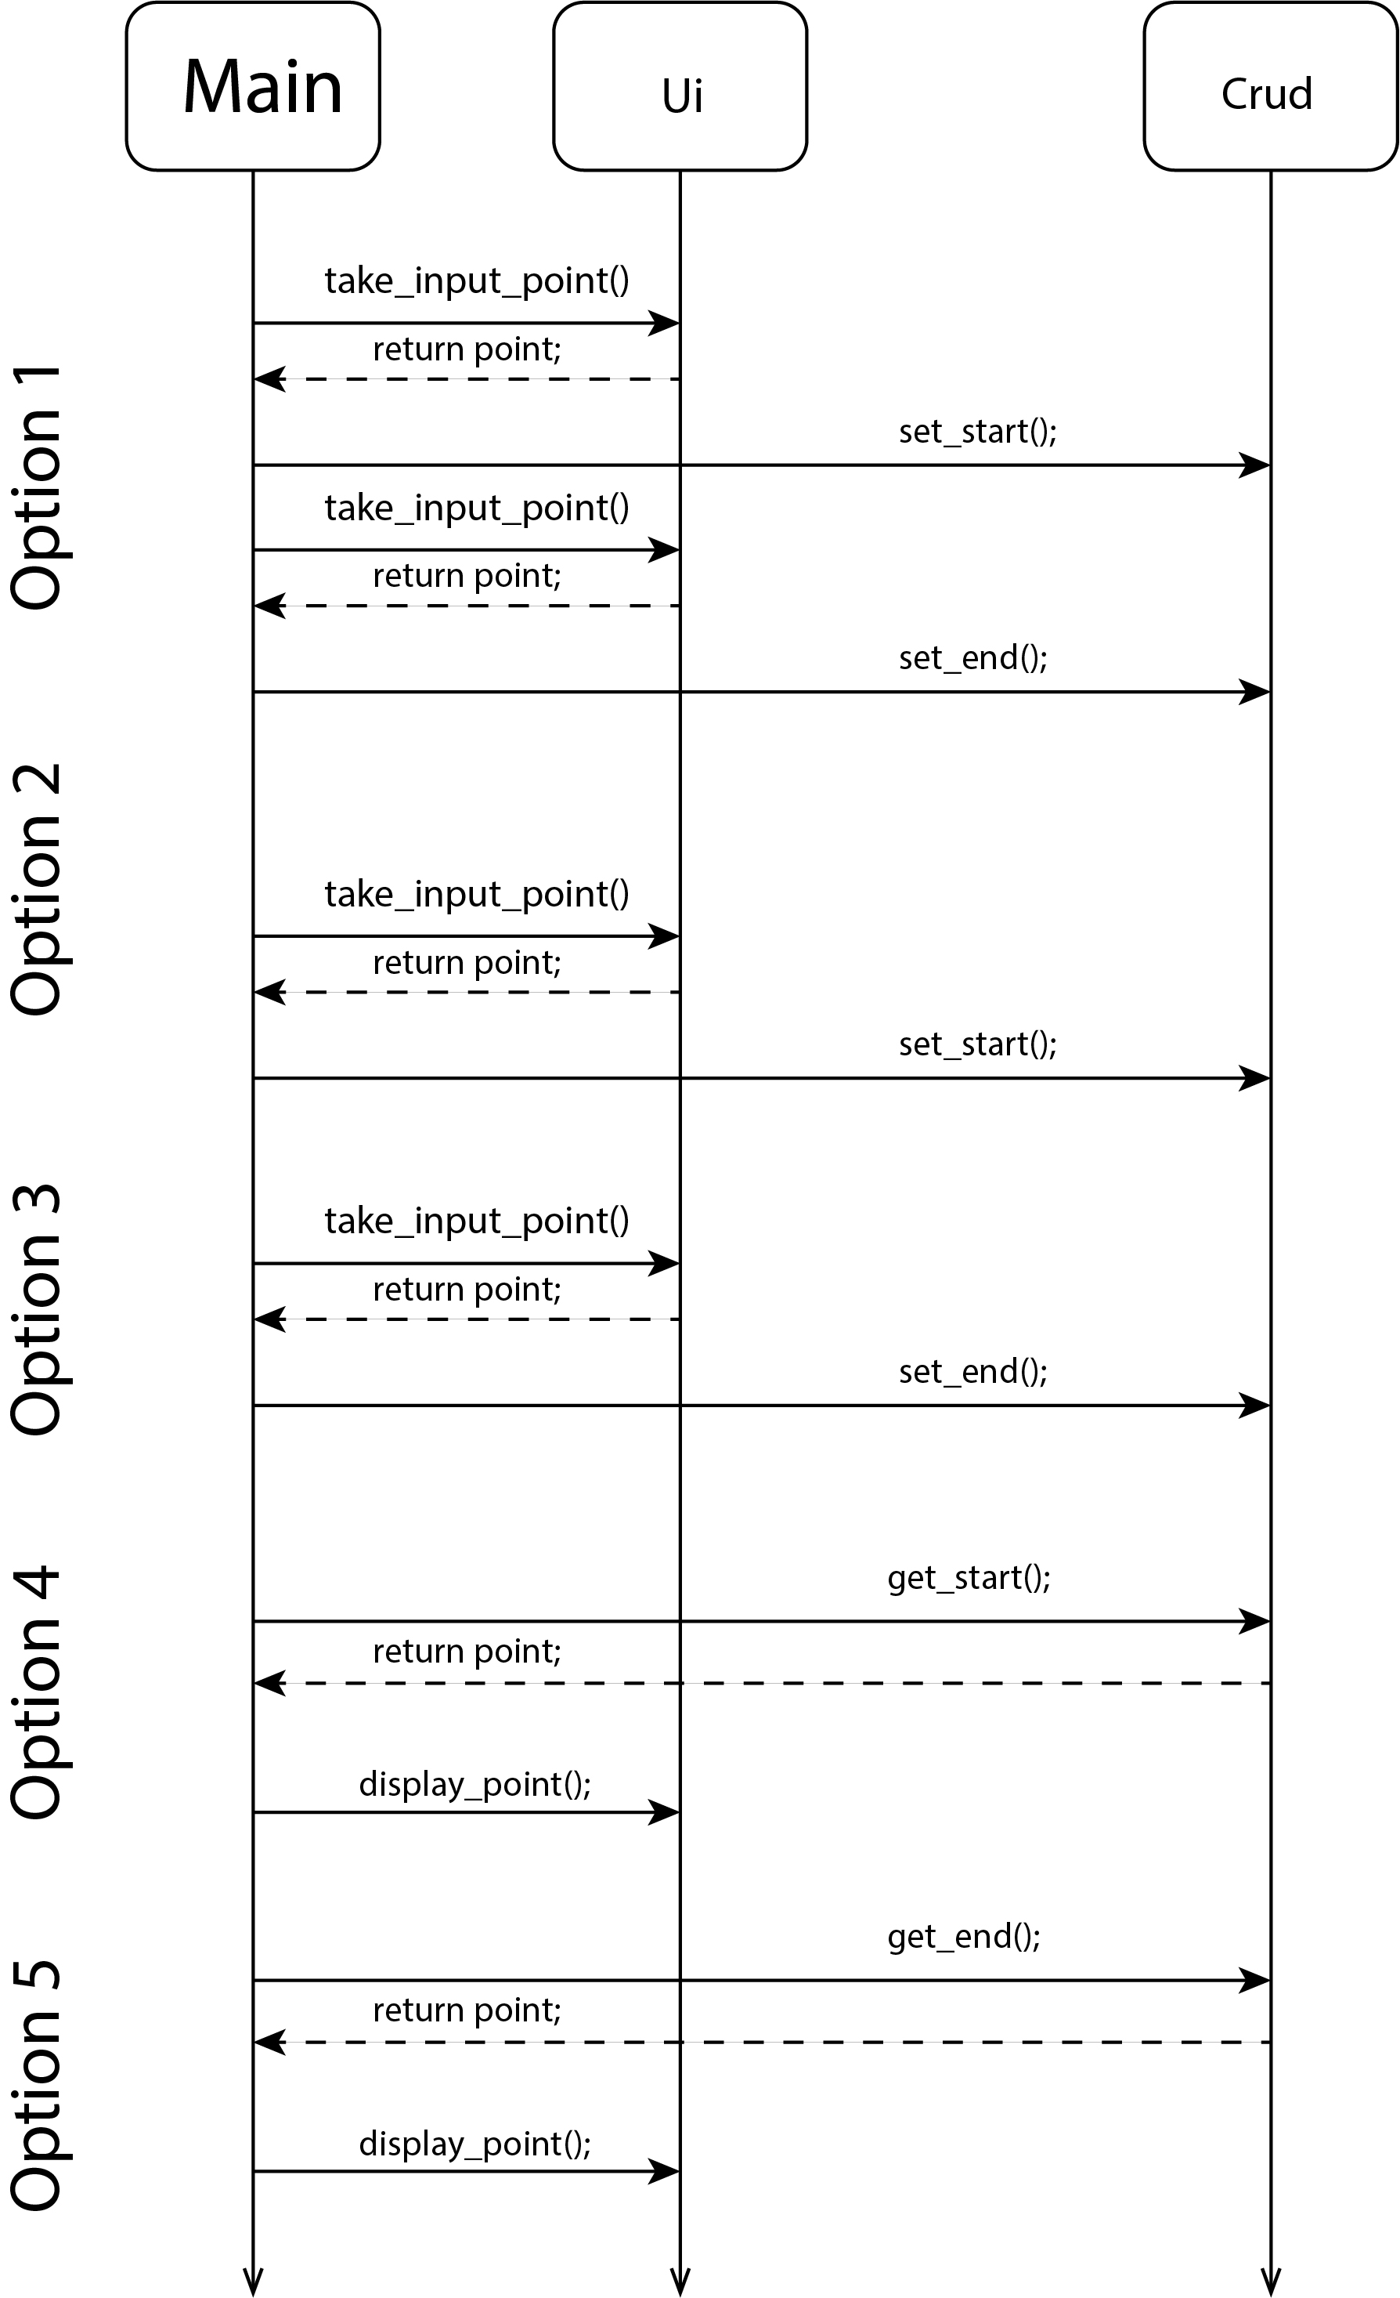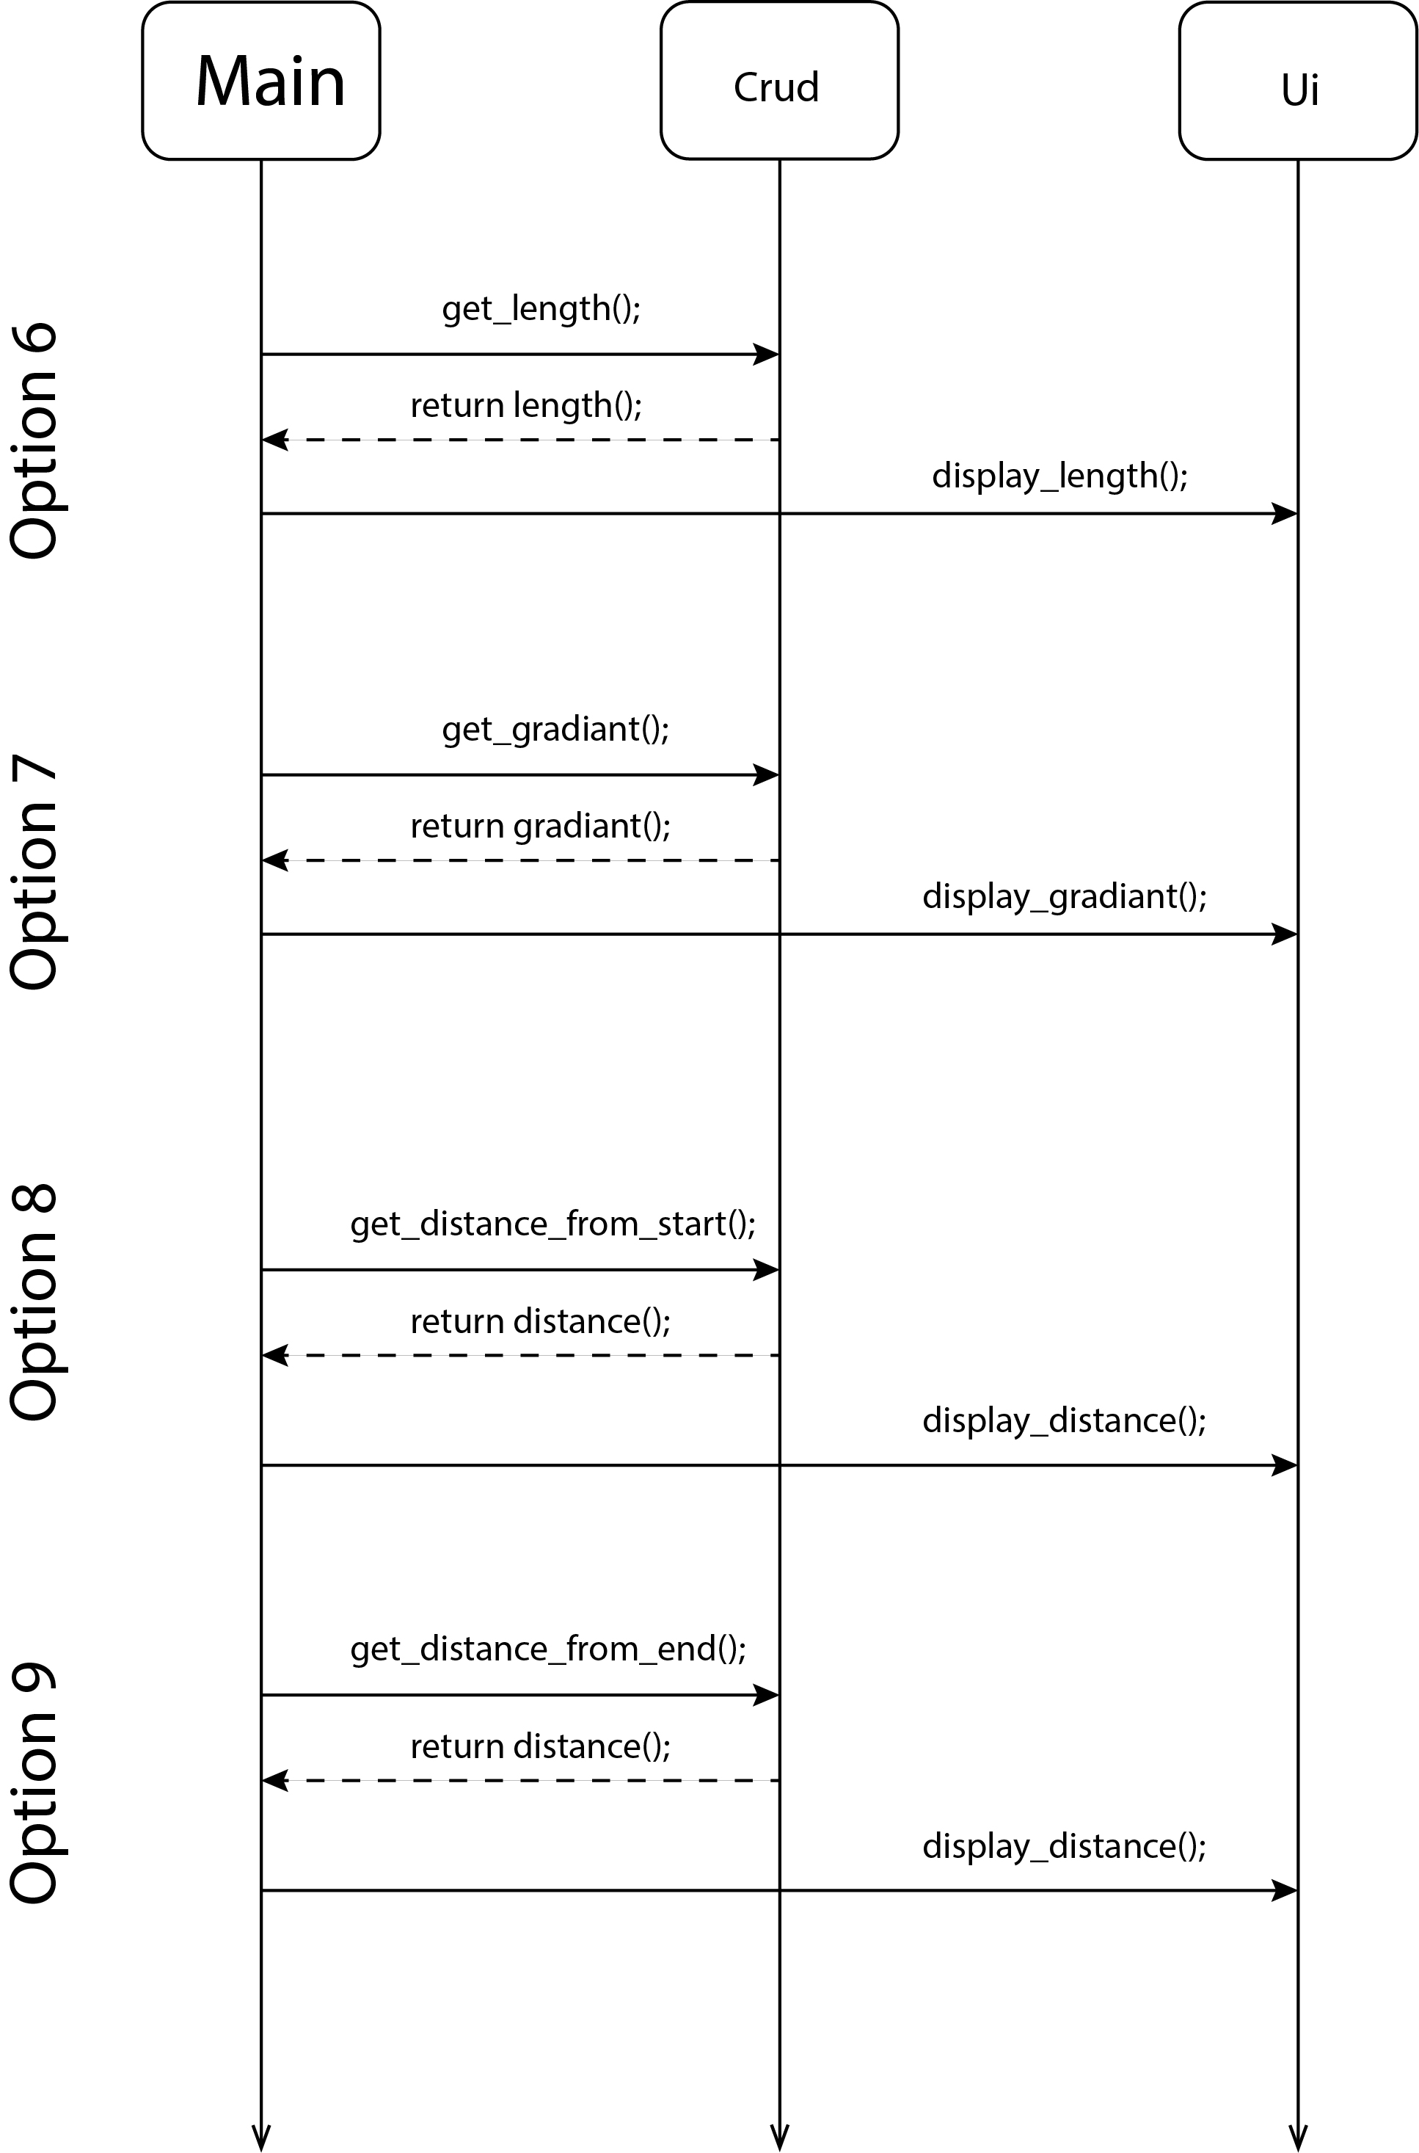

# **POINT OF SALE**

## **Case Study Scenario**

Miss Client wants to develop a software system for her departmental store. She wants this

system to have the following functionalities.

As an Admin, she can

Add Products.

● View All Products.

● Find Product with Highest Unit Price.

● View Sales Tax of All Products.

● Products to be Ordered. (less than threshold)

Following is the information that is required to save for the product.

Name of Product. Product Category. Product Price. Available Stock Quantity. Minimum

Stock threshold Quantity after which the owner wants to order the product.

On All Grocery type of products, the sales tax is 10%, on all fruit types the tax is 5% and

if there is any other type the tax is 15%

She also wants that

1. The Customers to view all the products

2. Customers can buy the products (When a customer buy a product then its

quantity should decrease from the stock)

3. Generate invoice (While calculating the price of the products that the

customer has bought, sales tax should be applied.)

## **Domain Model with only the Class names**

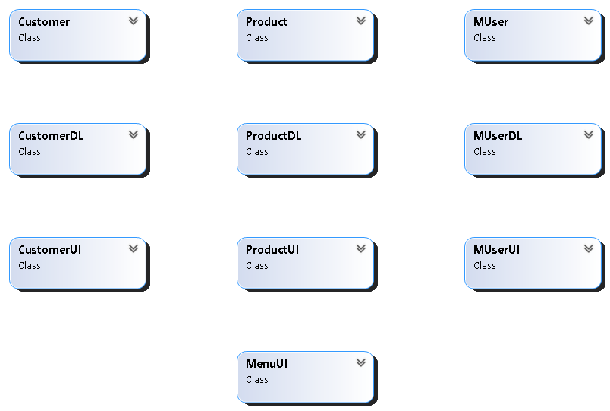

## **Domain Model with Relations and Constraints**

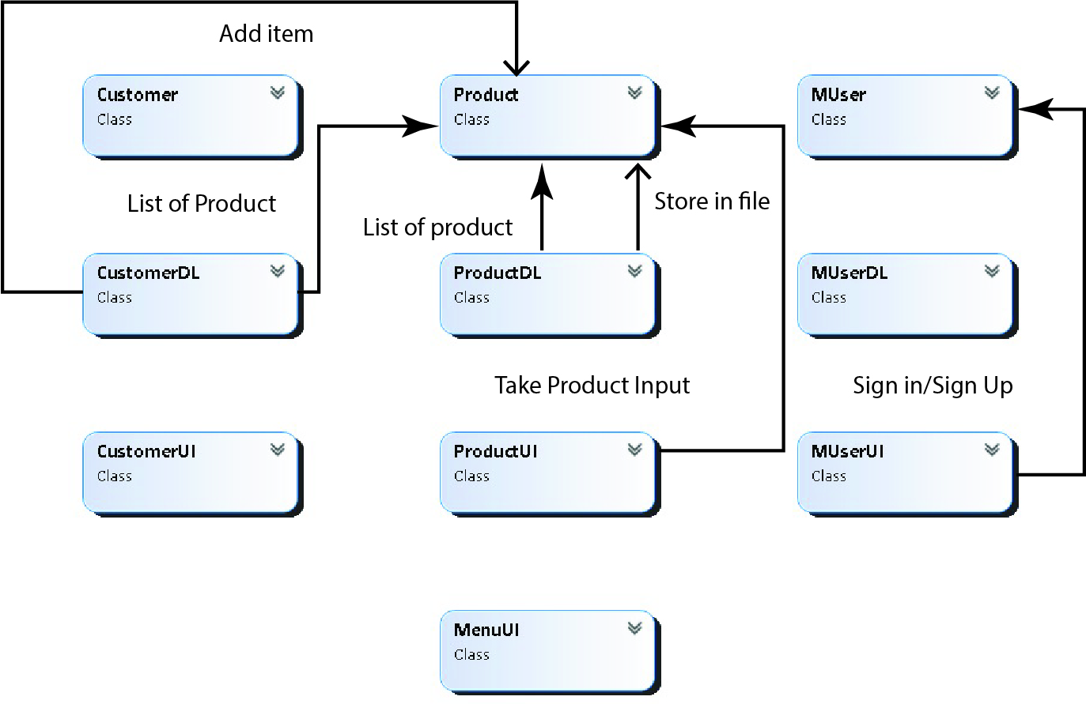

## **Class Diagram**

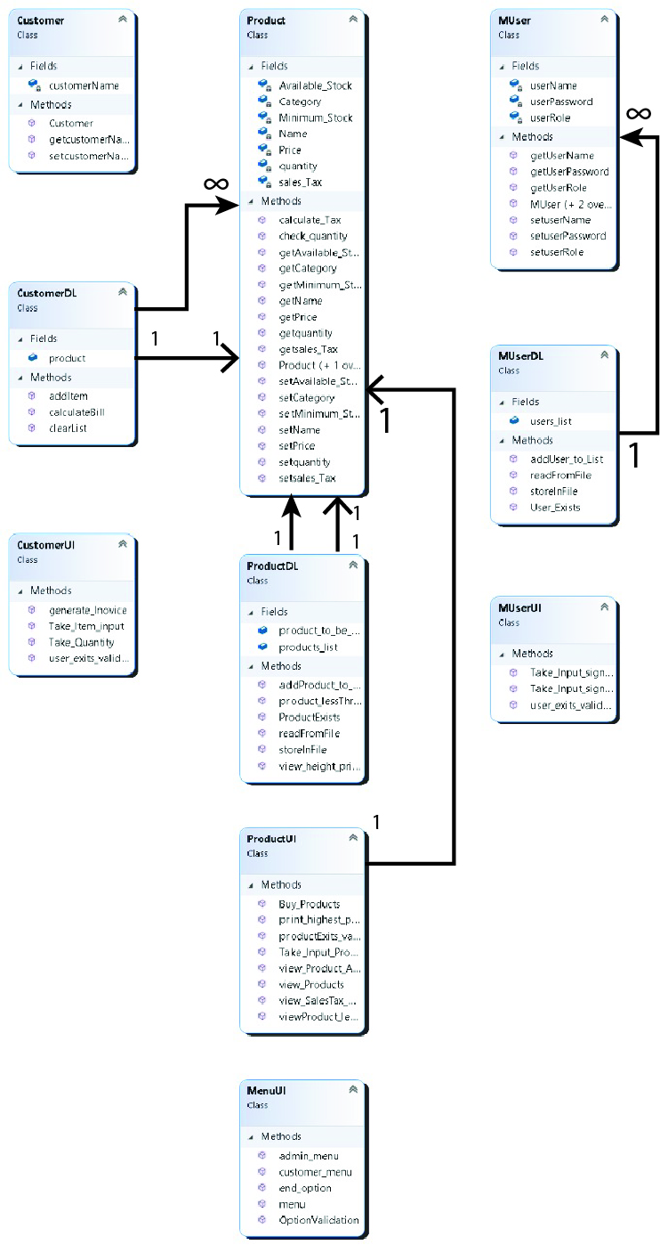

## **Full Code**

class Customer

{

private string customerName;

public Customer(string customerName)

{

this.customerName = customerName;

}

public string getcustomerName() { return customerName; }

public void setcustomerName(string customerName) { this.customerName=customerName; }

}

class MUser

{

private string userName;

private string userPassword;

private string userRole;

public MUser() { }

public MUser(string userName, string userPassword, string userRole)

{

this.userName = userName;

this.userPassword = userPassword;

this.userRole = userRole;

}

public MUser(string userName, string userPassword)

{

this.userName = userName;

this.userPassword = userPassword;

}

public string getUserName()

{

return userName;

}

public string getUserPassword()

{

return userPassword;

}

public string getUserRole()

{

return userRole;

}

public void setuserName(string userName) { this.userName = userName; }

public void setuserPassword(string userPassword) { this.userPassword = userPassword; }

public void setuserRole(string userRole) { this.userRole = userRole; }

}

class Product

{

private string Name;

private string Category;

private float Price;

private int Available_Stock;

private int Minimum_Stock;

private float sales_Tax;

private int quantity;

public Product() { }

public int getquantity() { return quantity; }

public void setquantity(int quantity)

{

this.quantity = quantity;

}

public string getName() { return Name; }

public string getCategory() { return Category; }

public float getPrice() { return Price; }

public int getAvailable_Stock() { return Available_Stock; }

public int getMinimum_Stock() { return Minimum_Stock; }

public float getsales_Tax() { return sales_Tax; }

public void setsales_Tax(float sales_Tax) { this.sales_Tax = sales_Tax; }

public void setName(string Name) { this.Name=Name; }

public void setCategory(string Category) { this.Category=Category; }

public void setPrice(float Price) { this.Price=Price; }

public void setAvailable_Stock(int Available_Stock) { this.Available_Stock=Available_Stock; }

public void setMinimum_Stock(int Minimum_Stock) { this.Minimum_Stock=Minimum_Stock; }

public Product(string Name, string Category, float Price, int Available_Stock, int Minimum_Stock, float sales_Tax)

{

this.Name = Name;

this.Category = Category;

this.Price = Price;

this.Available_Stock = Available_Stock;

this.Minimum_Stock = Minimum_Stock;

this.sales_Tax = sales_Tax;

}

public void calculate_Tax()

{

float tax = 0;

if (Category == "Grocery")

{

tax = (0.1f * Price);

}

else if (Category == "fruit")

{

tax = (0.05f * Price);

}

else

{

tax = (0.15f * Price);

}

setsales_Tax(tax);

}

public bool check_quantity()

{

if (Available_Stock < Minimum_Stock)

{

return true;

}

return false;

}

}

class CustomerDL

{

public static List<Product> product = new List<Product>();

public static void addItem(Product products)

{

product.Add(products);

}

public static float calculateBill()

{

float totalbill = 0;

for (int i = 0; i < product.Count; i++)

{

totalbill = totalbill + product[i].getquantity() * (product[i].getPrice() + product[i].getsales_Tax());

}

return totalbill;

}

public static void clearList()

{

product.Clear();

}

}

class MUserDL

{

public static List<MUser> users_list = new List<MUser>();

public static int User_Exists(MUser user)

{

for (int i = 0; i < users_list.Count; i++)

{

if (users_list[i].getUserName()== user.getUserName()&& users_list[i].getUserPassword()== user.getUserPassword())

{

return i;

}

}

return -1;

}

public static void addUser_to_List(MUser user)

{

users_list.Add(user);

}

public static void storeInFile(string path,MUser user)

{

StreamWriter file = new StreamWriter(path, true);

file.WriteLine(user.getUserName() + "," + user.getUserPassword() + "," + user.getUserRole());

file.Flush();

file.Close();

}

public static bool readFromFile(string path)

{

if (File.Exists(path))

{

StreamReader file = new StreamReader(path);

string line = "";

while ((line = file.ReadLine()) != null)

{

string[] splitLine = line.Split(',');

string name = splitLine[0];

string pasword = splitLine[1];

string role = splitLine[2];

MUser mUser = new MUser(name, pasword, role);

addUser_to_List(mUser);

}

file.Close();

return true;

}

else

{

return false;

}

}

}

class ProductDL

{

public static List<Product> products_list = new List<Product>();

public static List<Product> product_to_be_ordred = new List<Product>();

public static void addProduct_to_List(Product product)

{

products_list.Add(product);

}

public static int view_height_price()

{

float value = products_list[0].getPrice();

int idx = 0;

for (int i = 0; i <products_list.Count; i++)

{

if (value < products_list[i].getPrice())

{

value = products_list[i].getPrice();

idx = i;

}

}

return idx;

}

public static void product_lessThreshold()

{

foreach (Product product in products_list)

{

bool is_less=product.check_quantity();

if (is_less)

{

product_to_be_ordred.Add(product);

}

}

}

public static Product ProductExists(string name)

{

foreach (Product product in products_list)

{

if (product.getName()== name)

{

return product;

}

}

return null;

}

public static void storeInFile(string path ,Product product)

{

StreamWriter file = new StreamWriter(path, true);

file.WriteLine(product.getName() + "," + product.getCategory() + "," + product.getPrice() + "," + product.getAvailable_Stock() + "," + product.getMinimum_Stock() + "," + product.getsales_Tax());

file.Flush();

file.Close();

}

public static bool readFromFile(string path)

{

if (File.Exists(path))

{

StreamReader file = new StreamReader(path);

string line = "";

while ((line = file.ReadLine()) != null)

{

string[] splitrecord = line.Split(',');

string name = splitrecord[0];

string catagory = splitrecord[1];

float price = float.Parse(splitrecord[2]);

int stock = int.Parse(splitrecord[3]);

int min_stock = int.Parse(splitrecord[4]);

float tax = float.Parse(splitrecord[5]);

Product product = new Product(name, catagory, price, stock, min_stock, tax);

addProduct_to_List(product);

}

file.Close();

return true;

}

else

{

return false;

}

class CustomerUI

{

public static void user_exits_validation()

{

Console.WriteLine("UserName already taken choose another..");

}

public static string Take_Item_input()

{

Console.WriteLine("Enter Product Name : ");

string name=(Console.ReadLine());

return name;

}

public static int Take_Quantity()

{

Console.WriteLine("Enter Product Quantity : ");

int quantity = int.Parse(Console.ReadLine());

return quantity;

}

public static void generate_Inovice(float bill)

{

Console.WriteLine("Your total Bill : " + bill);

}

}

class MenuUI

{

public static void end_option()

{

Console.WriteLine("Press any key to continue.....");

Console.ReadKey();

Console.Clear();

}

public static int menu()

{

Console.WriteLine("1.SignIn");

Console.WriteLine("2.SignUp");

Console.WriteLine("3.Exit");

Console.WriteLine();

Console.WriteLine("Your Option---");

int op = int.Parse(Console.ReadLine());

return op;

}

public static int admin_menu()

{

Console.WriteLine("1. Add Product.");

Console.WriteLine("2.View All Products.");

Console.WriteLine("3.Find Product with Highest Unit Price.");

Console.WriteLine("4.View Sales Tax of All Products.");

Console.WriteLine("5.Products to be Ordered.");

Console.WriteLine("6.Exit");

Console.WriteLine();

Console.WriteLine("Your Option---");

int op = int.Parse(Console.ReadLine());

return op;

}

public static int customer_menu()

{

Console.WriteLine("1. View all the products");

Console.WriteLine("2.Buy the products");

Console.WriteLine("3.Generate invoice");

Console.WriteLine("4.Exit");

Console.WriteLine();

Console.WriteLine("Your Option---");

int op = int.Parse(Console.ReadLine());

return op;

}

public static void OptionValidation()

{

Console.WriteLine("Enter a valid input...");

}

}

class ProductUI

{

public static Product Take_Input_Product()

{

Product product = new Product();

Console.WriteLine("Enter Product Name : ");

product.setName(Console.ReadLine());

Console.WriteLine("Enter Product Category : ");

product.setCategory(Console.ReadLine());

Console.WriteLine("Enter Product Price : ");

product.setPrice(int.Parse(Console.ReadLine()));

Console.WriteLine("Enter Product Quantity : ");

product.setAvailable_Stock(int.Parse(Console.ReadLine()));

Console.WriteLine("Enter Product Minimum Quantity : ");

product.setMinimum_Stock(int.Parse(Console.ReadLine()));

product.calculate_Tax();

return product;

}

public static void productExits_validation()

{

Console.WriteLine("No such product exits...");

}

public static void view_Products()

{

if (DL.ProductDL.products_list[0] != null)

{

Console.WriteLine("Name\t\t\tPrice\t\t\tQuantity");

foreach (Product product in DL.ProductDL.products_list)

{

Console.WriteLine(product.getName()+ "\t\t\t" + product.getPrice()+ "\t\t\t" + product.getAvailable_Stock());

}

}

else

{

Console.WriteLine("No Product available...");

}

}

public static void print_highest_product(int idx)

{

Console.WriteLine(ProductDL.products_list[idx].getName()+ "\t\t\t" + ProductDL.products_list[idx].getPrice()+ "\t\t\t" + ProductDL.products_list[idx].getAvailable_Stock()+ "\t\t\t" + DL.ProductDL.products_list[idx].getMinimum_Stock());

}

public static void view_SalesTax_Of_AllProducts()

{

if (ProductDL.products_list[0] != null)

{

Console.WriteLine("Name\t\t\tPrice\t\t\tQuantity\t\t\tTax");

foreach (Product product in ProductDL.products_list)

{

Console.WriteLine(product.getName()+ "\t\t\t" + product.getPrice()+ "\t\t\t" + product.getAvailable_Stock()+ "\t\t\t" + product.getsales_Tax());

}

}

else

{

Console.WriteLine("No Product available...");

}

}

public static int Buy_Products()

{

Console.WriteLine("How many products you want to buy?");

int n = int.Parse(Console.ReadLine());

return n;

}

public static void view_Product_All_Properties()

{

if (DL.ProductDL.products_list[0] != null)

{

Console.WriteLine("Name\t\t\tPrice\t\t\tQuantity\t\t\tMinimum Quantity");

foreach (Product product in DL.ProductDL.products_list)

{

Console.WriteLine(product.getName()+ "\t\t\t" + product.getPrice()+ "\t\t\t" + product.getAvailable_Stock()+ "\t\t\t" + product.getMinimum_Stock());

}

}

else

{

Console.WriteLine("No Product is added yet...");

}

}

public static void viewProduct_lessThreshold()

{

if (DL.ProductDL.product_to_be_ordred.Count != 0)

{

Console.WriteLine("Name\t\t\tPrice\t\t\tQuantity");

foreach (Product product in DL.ProductDL.product_to_be_ordred)

{

Console.WriteLine(product.getName()+ "\t\t\t" + product.getPrice()+ "\t\t\t" + product.getAvailable_Stock());

}

}

else

{

Console.WriteLine("No such product uptill now...");

}

}

}

}

}

class Program

{

static void Main(string[] args)

{

string userPath = "Customer.txt";

string productPath = "Product.txt";

if (MUserDL.readFromFile(userPath))

{

Console.WriteLine("User file loaded");

}

if (ProductDL.readFromFile(productPath))

{

Console.WriteLine("Product file loaded");

}

while (true)

{

int op = MenuUI.menu();

MenuUI.end_option();

if (op == 1)

{

MUser user = MUserUI.Take_Input_signIn();

MenuUI.end_option();

int is_valid = MUserDL.User_Exists(user);

if (is_valid != -1)

{

if (MUserDL.users_list[is_valid].getUserRole() == "admin")

{

while (true)

{

int admin_op = MenuUI.admin_menu();

MenuUI.end_option();

if (admin_op == 1)

{

Product product = ProductUI.Take_Input_Product();

ProductDL.addProduct_to_List(product);

ProductDL.storeInFile(productPath, product);

}

else if (admin_op == 2)

{

ProductUI.view_Product_All_Properties();

}

else if (admin_op == 3)

{

int idx = DL.ProductDL.view_height_price();

ProductUI.print_highest_product(idx);

}

else if (admin_op == 4)

{

ProductUI.view_SalesTax_Of_AllProducts();

}

else if (admin_op == 5)

{

ProductDL.product_lessThreshold();

ProductUI.viewProduct_lessThreshold();

}

else if (admin_op == 6)

{

break;

}

else

{

MenuUI.OptionValidation();

}

MenuUI.end_option();

}

}

else

{

while (true)

{

int customer_op = MenuUI.customer_menu();

MenuUI.end_option();

Customer customer = new Customer(user.getUserName());

if (customer_op == 1)

{

ProductUI.view_Products();

}

else if (customer_op == 2)

{

int number = ProductUI.Buy_Products();

for (int i = 0; i < number; i++)

{

string name = CustomerUI.Take_Item_input();

int quantity = CustomerUI.Take_Quantity();

Product itemExists = ProductDL.ProductExists(name);

if (itemExists != null)

{

itemExists.setAvailable_Stock(itemExists.getAvailable_Stock() - quantity);

itemExists.setquantity(quantity);

CustomerDL.addItem(itemExists);

}

else

{

ProductUI.productExits_validation();

i--;

}

}

}

else if (customer_op == 3)

{

List<Product> list = CustomerDL.product;

float bill = CustomerDL.calculateBill();

CustomerUI.generate_Inovice(bill);

CustomerDL.clearList();

}

else if (customer_op == 4) { break; }

else

{

MenuUI.OptionValidation();

}

MenuUI.end_option();

}

}

}

else

{

MenuUI.OptionValidation();

MenuUI.end_option();

}

}

else if (op == 2)

{

MUser user;

while (true)

{

user = MUserUI.Take_Input_signUp();

int idx = MUserDL.User_Exists(user);

foreach(MUser person in MUserDL.users_list)

{

if (person.getUserRole() != "admin")

{

person.setuserRole("customer");

}

}

if (idx == -1)

{

break;

}

}

MUserDL.addUser_to_List(user);

MUserDL.storeInFile(userPath, user);

}

else if (op == 3) { break; }

else

{

MenuUI.OptionValidation();

}

MenuUI.end_option();

}

}

}

## **Sequence Diagrams**

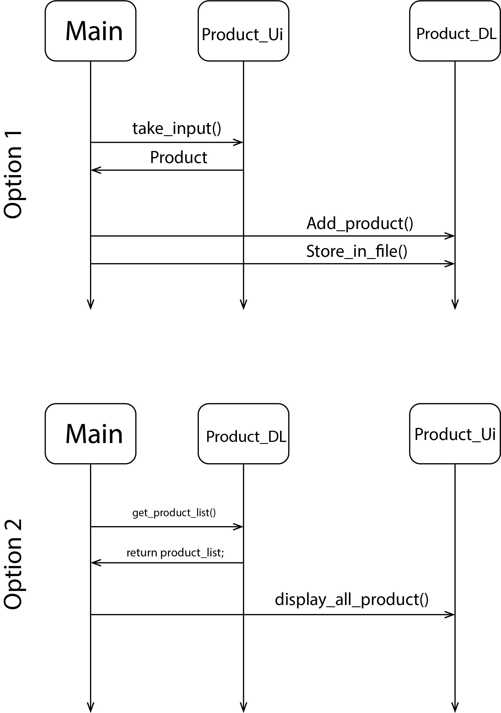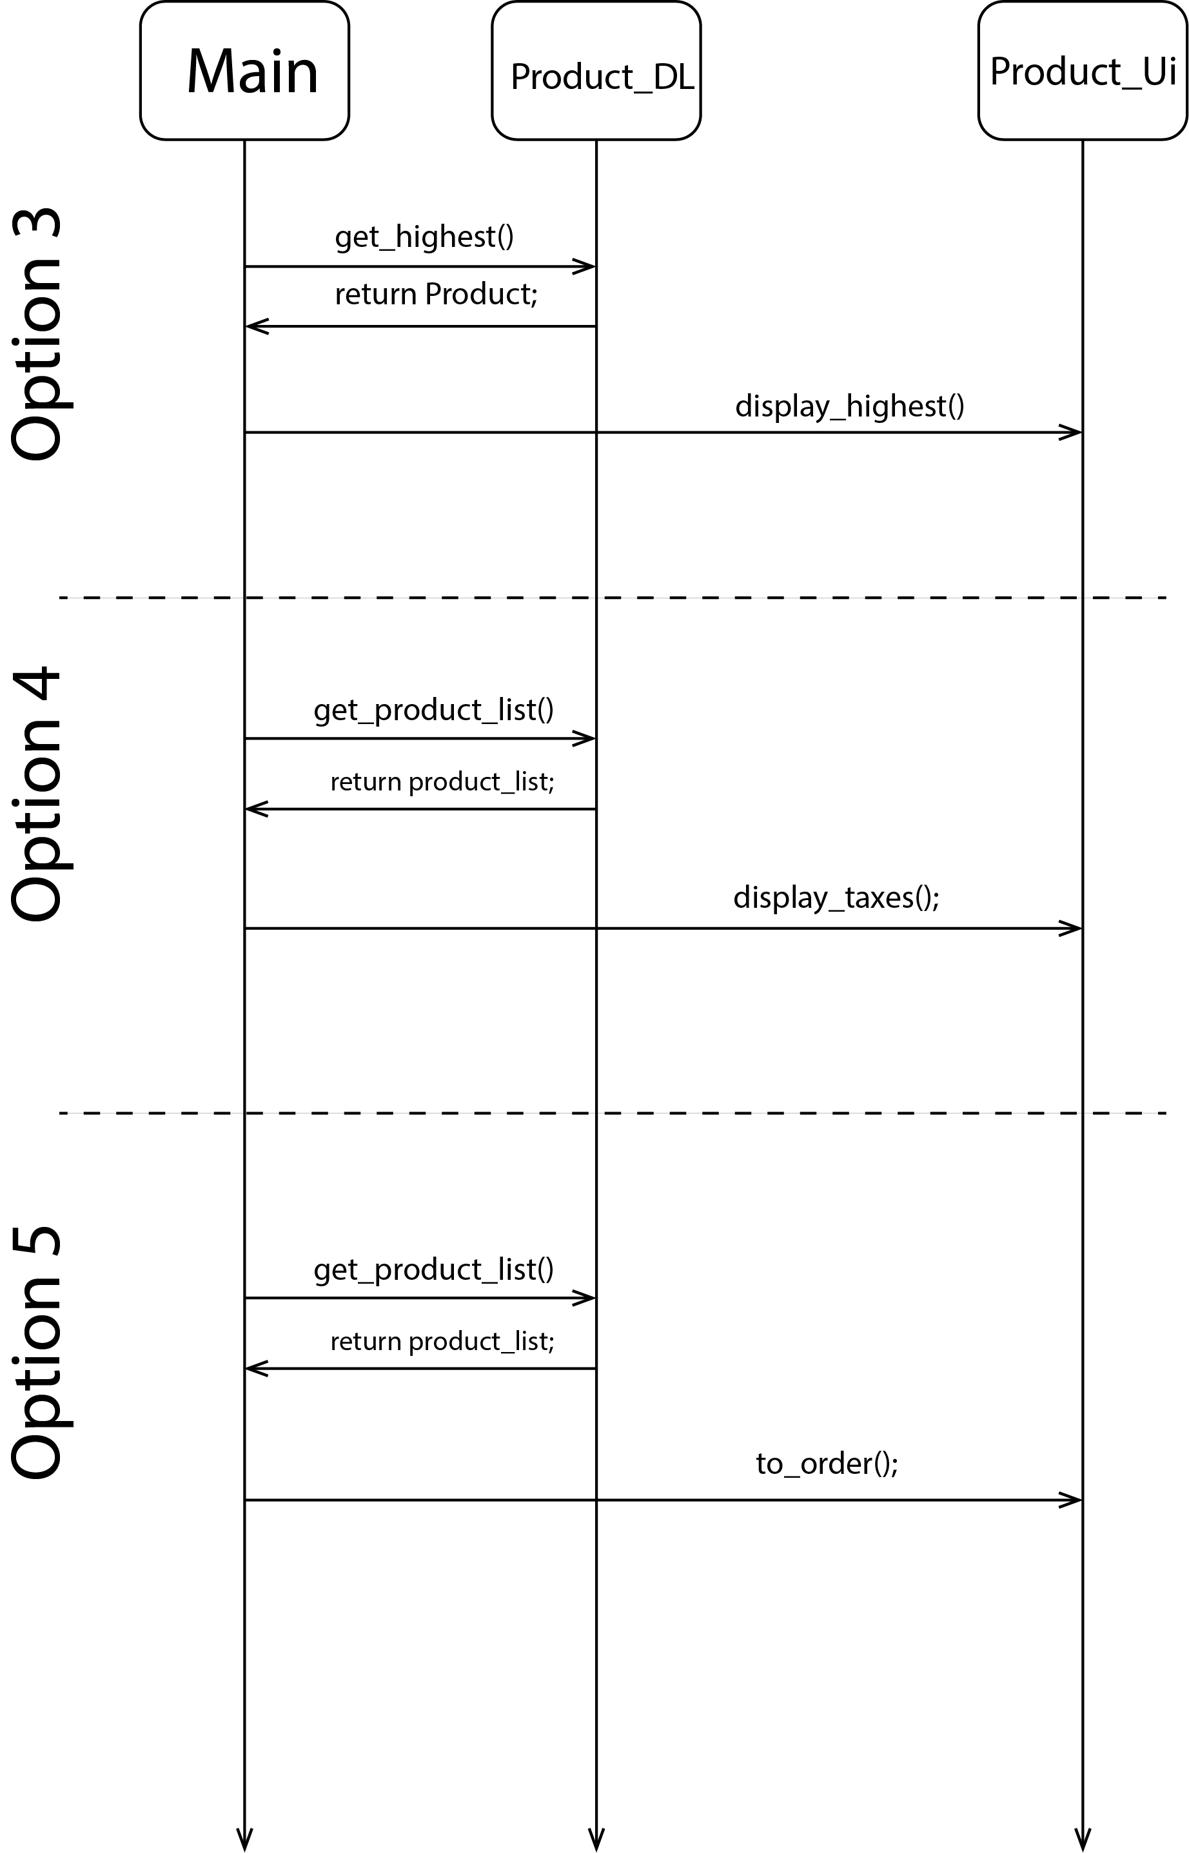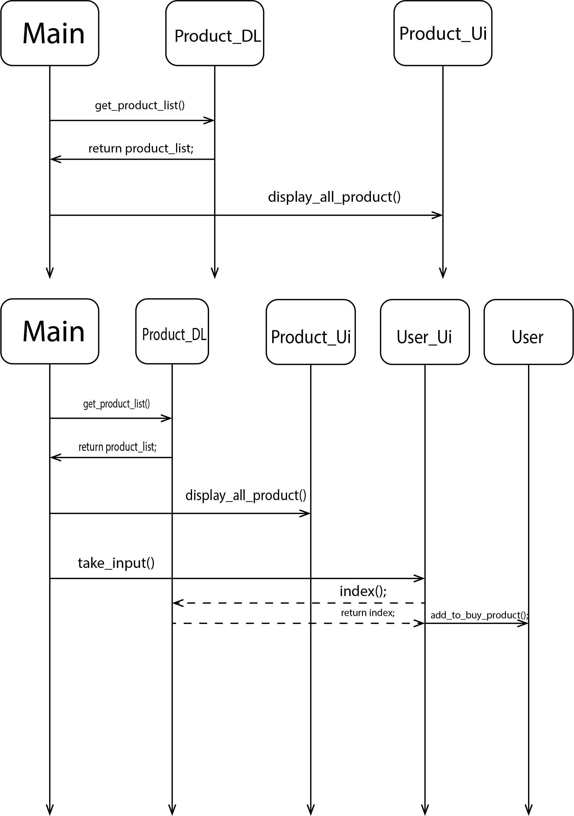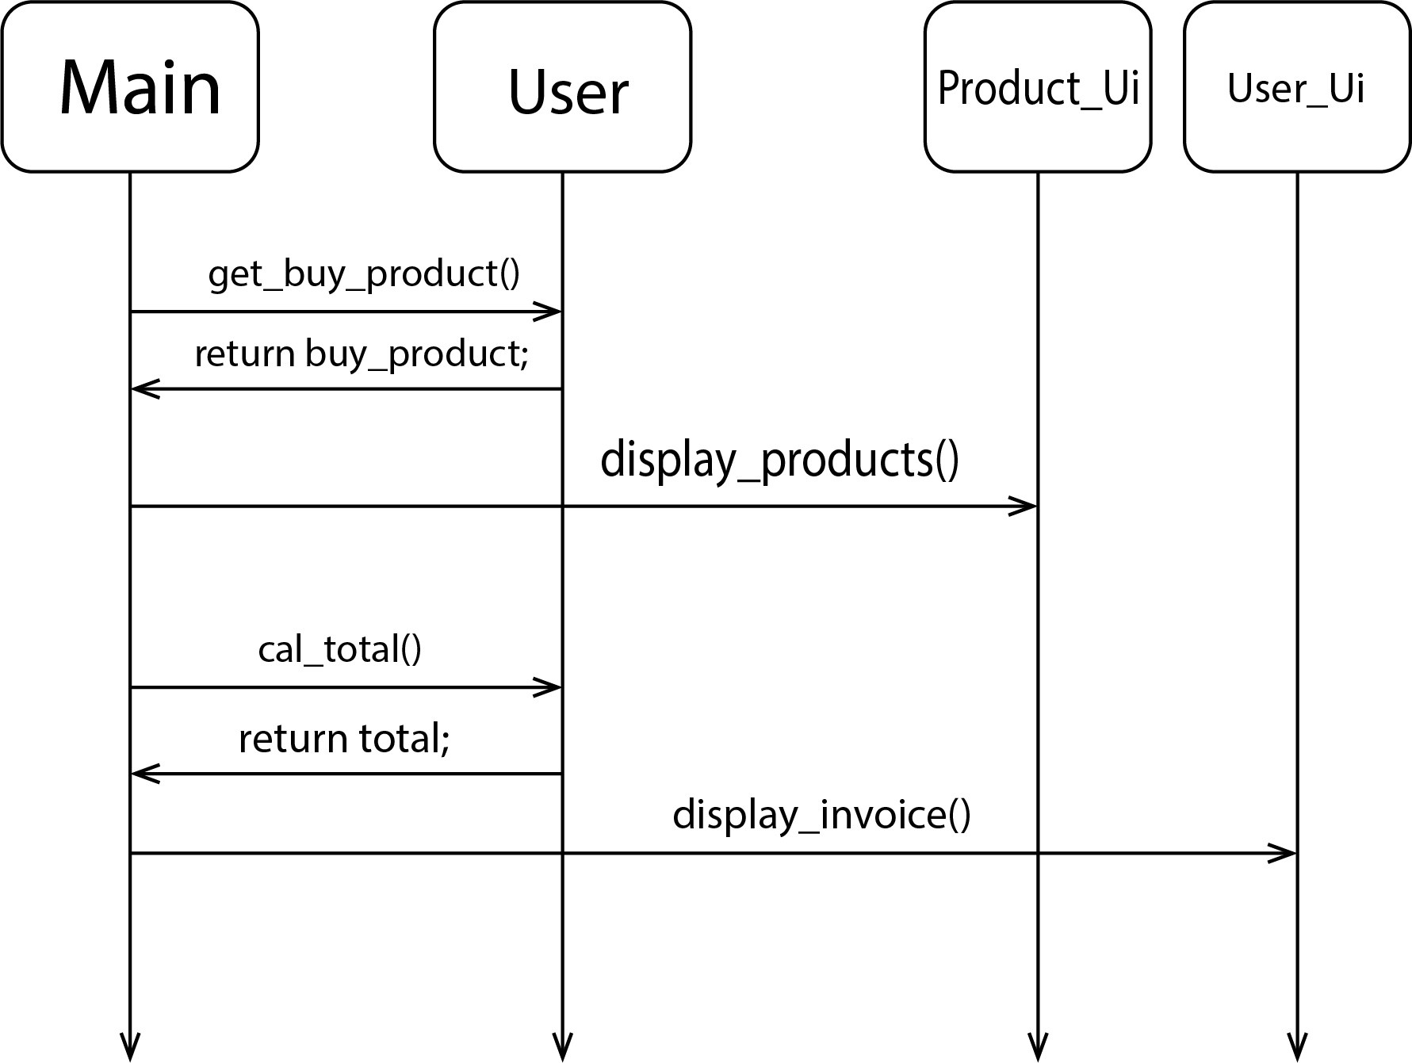

# **TESHA’s COFFE SHOP**

## **Case Study Scenario**

Create a Class MenuItem, which has three instances

1. name: name of the item

2. type: whether food or a drink

3. price: price of the item

Write a class called CoffeeShop, which has three instance variables:

1. name : a string (basically, of the shop)

2. menu : an list of items (of object type), with each item containing the item (name of the item),

type (whether food or a drink) and price.

3. orders : an empty list of string type.

And a parameterized constructor which takes the name of the CoffeeShop as a parameter.

and eight methods:

1. addMenuItem: adds the menu item in the list of menu

2. addOrder: adds the name of the item to the end of the orders list if it exists on the menu.

Otherwise, return "This item is currently unavailable!"

3. fulfillOrder: if the orders list is not empty, return "The {item} is ready!" and make the list empty.

If the order list is empty, return "All orders have been fulfilled!"

4. listOrders: returns the list of orders taken, otherwise null.

5. dueAmount: returns the total amount due for the orders taken.

6. cheapestItem: returns the name of the cheapest item on the menu.

7. drinksOnly: returns only the item names of type drink from the menu.

8. foodOnly: returns only the item names of type food from the menu.

## **Domain Model with only the Class names**

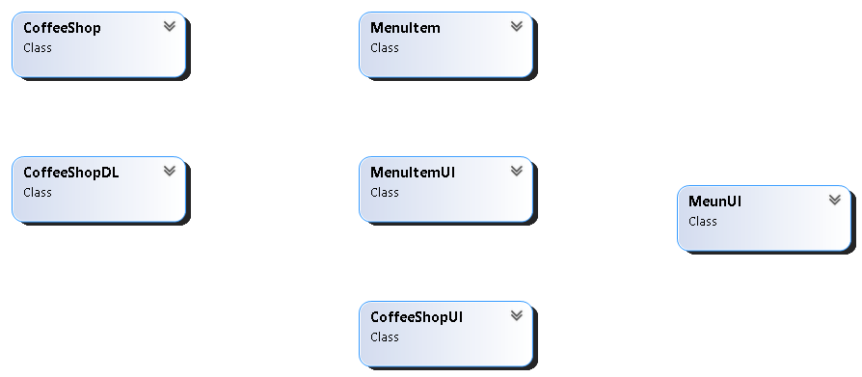

## **Domain Model with Relations and Constraints**

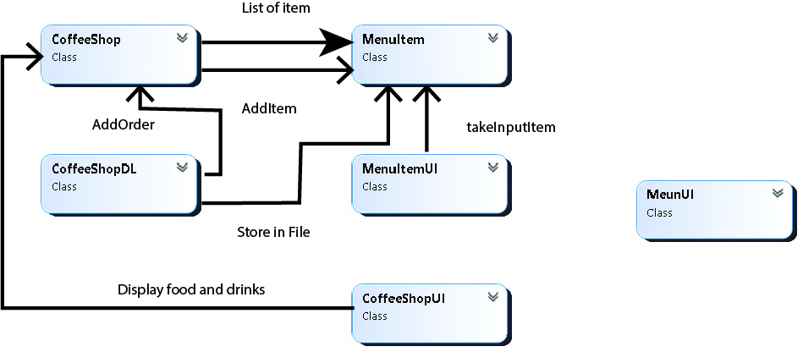

## **Class Diagram**

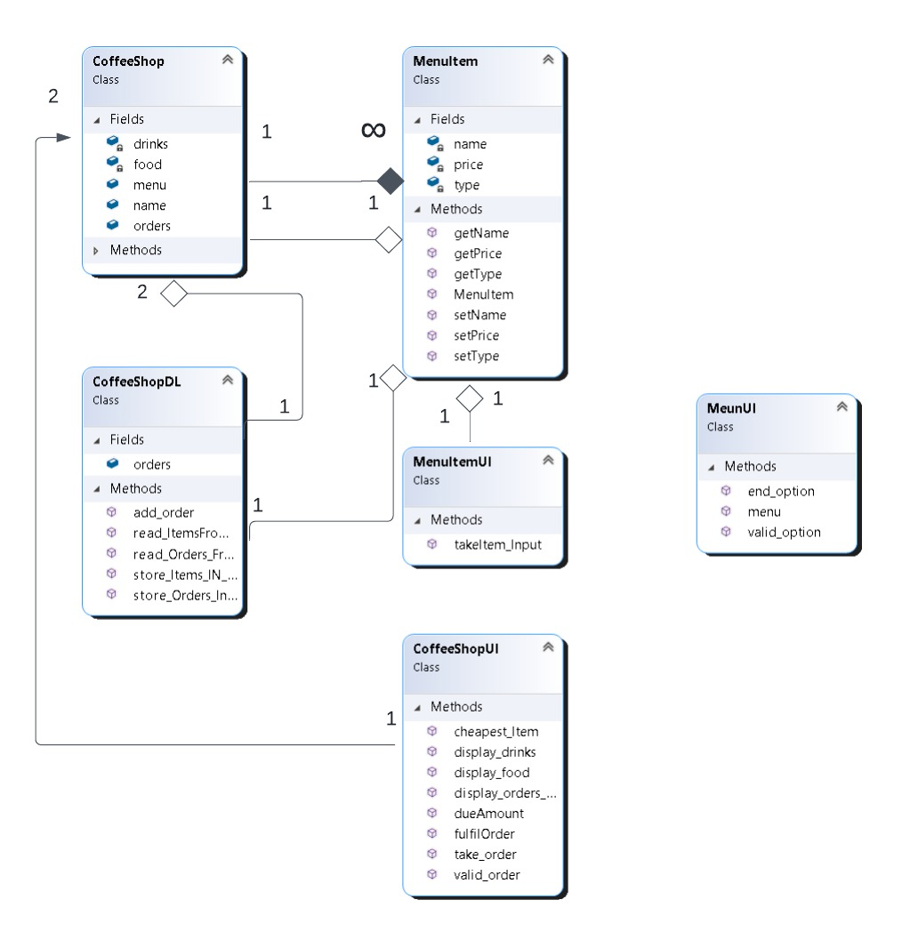

## **Full Code**

internal class Coffee_shop

{

public string name;

public List<Menu_Item> items=new List<Menu_Item>();

public List<Menu_Item> orders=new List<Menu_Item>();

public Coffee_shop() { }

public Coffee_shop(string name)

{

this.name = name;

}

public void Add_items(Menu_Item input)

{

items.Add(input);

}

public void Add_orders(Menu_Item input)

{

orders.Add(input);

}

}

internal class Menu_Item

{

private string name;

private string type;

private float price;

public string Name

{

get { return name; }

set { name = value; }

}

public string Type

{

get { return type; }

set { type = value; }

}

public float Price

{

get { return price; }

set { price = value; }

}

public Menu_Item(string name,int choice,float price)

{

this.name = name;

this.price = price;

if(choice == 1)

{

type = "drink";

}

else

{

type = "food";

}

}

}

internal class Crud_menu

{

public static Coffee_shop coffee_shop = new Coffee_shop();

public static List<Menu_Item> get_items()

{

return coffee_shop.items;

}

public static void add_item(Menu_Item input)

{

coffee_shop.items.Add(input);

}

public static void add_order(Menu_Item input)

{

coffee_shop.orders.Add(input);

}

public static Menu_Item give_index(string str)

{

for (int i = 0; i < coffee_shop.items.Count; i++)

{

if (str == coffee_shop.items[i].Name)

{

return coffee_shop.items[i];

}

}

return null;

}

public static Menu_Item Cheapest()

{

float price = 0.0f;

int index = -1;

for (int i = 0; i < coffee_shop.items.Count; i++)

{

if (price > coffee_shop.items[i].Price)

{

price = coffee_shop.items[i].Price;

index = i;

}

}

if (index != -1)

{

return coffee_shop.items[index];

}

else

{

return null;

}

}

public static bool check_orders()

{

if (coffee_shop.orders.Count > 0)

{

return true;

}

else

{

return false;

}

}

public static List<Menu_Item> get_orders()

{

return coffee_shop.orders;

}

public static float get_total()

{

float count = 0;

for (int i = 0; i < coffee_shop.orders.Count; i++)

{

count = count + coffee_shop.orders[i].Price;

}

coffee_shop.orders.Clear();

return count;

}

}

internal class Menu_item_Ui

{

public static Menu_Item Add_item()

{

Console.WriteLine("Enter the name of Item : ");

string name = Console.ReadLine();

Console.WriteLine("1) Drink");

Console.WriteLine("2) Food");

Console.Write("Enter the type of item : ");

int choice = int.Parse(Console.ReadLine());

Console.Write("Enter the price : ");

float price = float.Parse(Console.ReadLine());

Menu_Item input = new Menu_Item(name, choice, price);

return input;

}

}

internal class Menu_Ui

{

public static char menu()

{

Console.WriteLine("1) Add Menu Item");

Console.WriteLine("2) View the cheapest item in the Menu");

Console.WriteLine("3) View the Drinks Menu");

Console.WriteLine("4) View the Food Menu");

Console.WriteLine("5) Add Order");

Console.WriteLine("6) Fulfil the Order");

Console.WriteLine("7) View the orders list");

Console.WriteLine("8) Total Payable Amount");

Console.WriteLine("9) EXIT");

Console.Write("Enter any option ...");

char op = Console.ReadLine()[0];

return op;

}

public static void clear_screen()

{

Console.Write("Press any key to continue...");

Console.ReadKey();

}

}

internal class Ui

{

public static Menu_Item add_Order()

{

Console.Write("Enter the name of Product : ");

string name = Console.ReadLine();

Menu_Item input=Crud_menu.give_index(name);

if(input == null)

{

Console.WriteLine("The Product Is not available .");

}

else

{

Console.WriteLine("Item has been ordered .");

return input;

}

return null;

}

public static void show_drinks(List<Menu_Item> items)

{

Console.WriteLine("Name\tPrice");

for (int i = 0; i < items.Count; i++)

{

if( items[i].Type =="drink")

{

Console.WriteLine(items[i].Name+"\t"+items[i].Price);

}

}

}

public static void show_food(List<Menu_Item> items)

{

Console.WriteLine("Name\tPrice");

for (int i = 0; i < items.Count; i++)

{

if (items[i].Type == "food")

{

Console.WriteLine(items[i].Name + "\t" + items[i].Price);

}

}

}

public static void display_all(List<Menu_Item> items)

{

Console.WriteLine("Name\tPrice");

for (int i = 0; i < items.Count; i++)

{

Console.WriteLine(items[i].Name+"\t"+ items[i].Price);

}

}

public static void display_minimum(Menu_Item min)

{

if(min != null)

{

Console.WriteLine("The Item with minimum Price "+min.Price+" is "+min.Name+" .");

}

else

{

Console.WriteLine("There are no Products .");

}

}

public static void show_orders()

{

if(Crud_menu.check_orders())

{

Console.WriteLine("The Item is ready .");

Crud_menu.coffee_shop.orders.Clear();

}

else

{

Console.WriteLine("All the orders have been fulfiled .");

}

}

public static void display_orders(List<Menu_Item> orders)

{

Console.WriteLine("Name\tPrice");

for (int i = 0; i < orders.Count; i++)

{

Console.WriteLine(orders[i].Name+"\t"+orders[i].Price);

}

}

public static void display_total(float total)

{

Console.WriteLine("The total amount is "+total+" .");

}

}

internal class Program

{

static void Main(string[] args)

{

while (true)

{

Console.Clear();

char op = Menu_Ui.menu();

if(op=='1')

{

Crud_menu.add_item(Menu_item_Ui.Add_item());

}

else if(op=='2')

{

Ui.display_minimum(Crud_menu.Cheapest());

}

else if(op=='3')

{

Ui.show_drinks(Crud_menu.get_items());

}

else if(op=='4')

{

Ui.show_food(Crud_menu.get_items());

}

else if(op=='5')

{

Ui.display_all(Crud_menu.get_items());

Menu_Item order;

if ((order = Ui.add_Order()) != null)

{

Crud_menu.add_order(order);

}

}

else if(op=='6')

{

Ui.show_orders();

}

else if(op=='7')

{

Ui.display_orders(Crud_menu.get_orders());

}

else if(op=='8')

{

Ui.display_total(Crud_menu.get_total());

Crud_menu.coffee_shop.orders.Clear();

}

else if(op=='9')

{

break;

}

Menu_Ui.clear_screen();

}

}

}

## **Sequence Diagram**

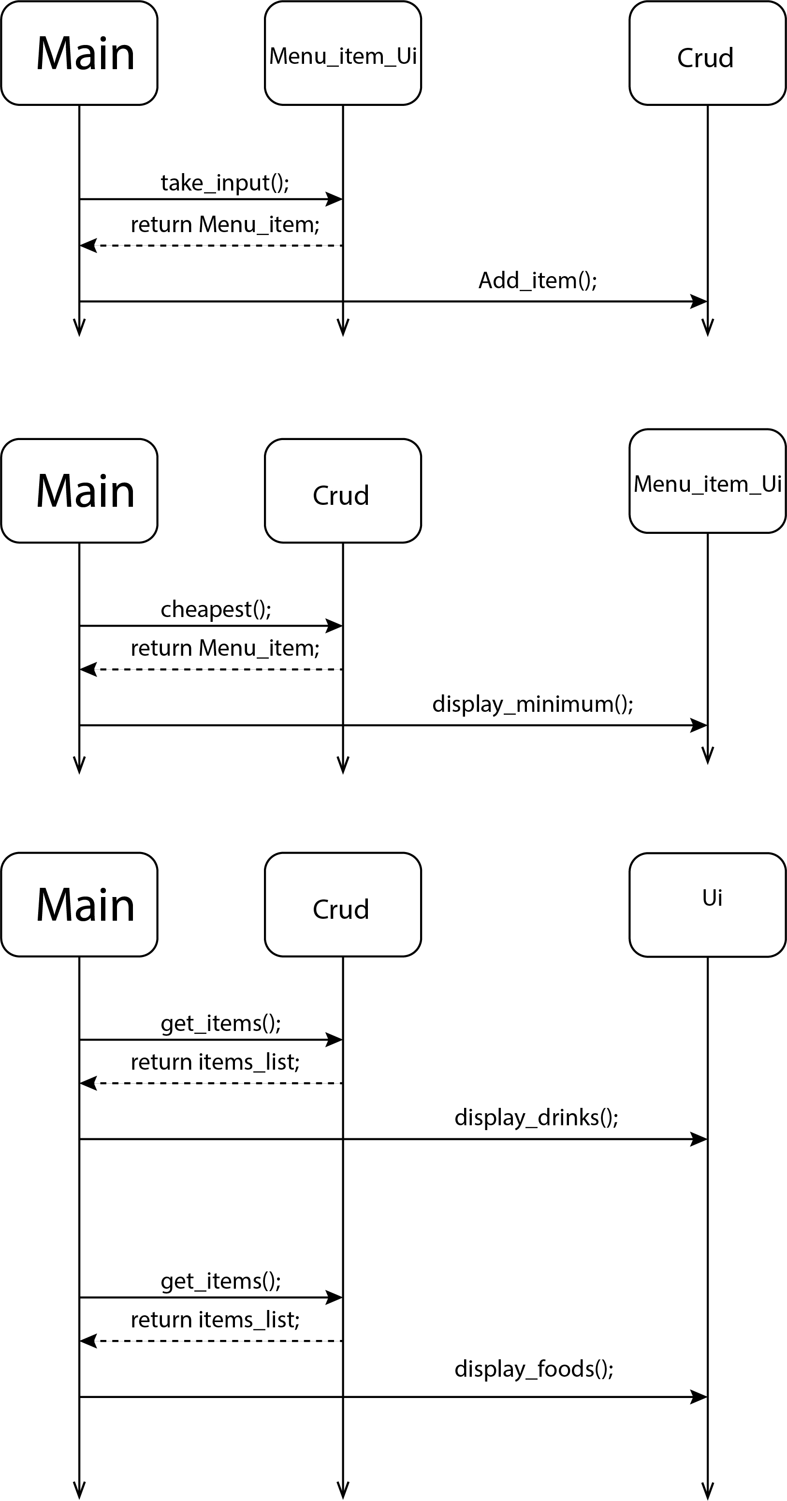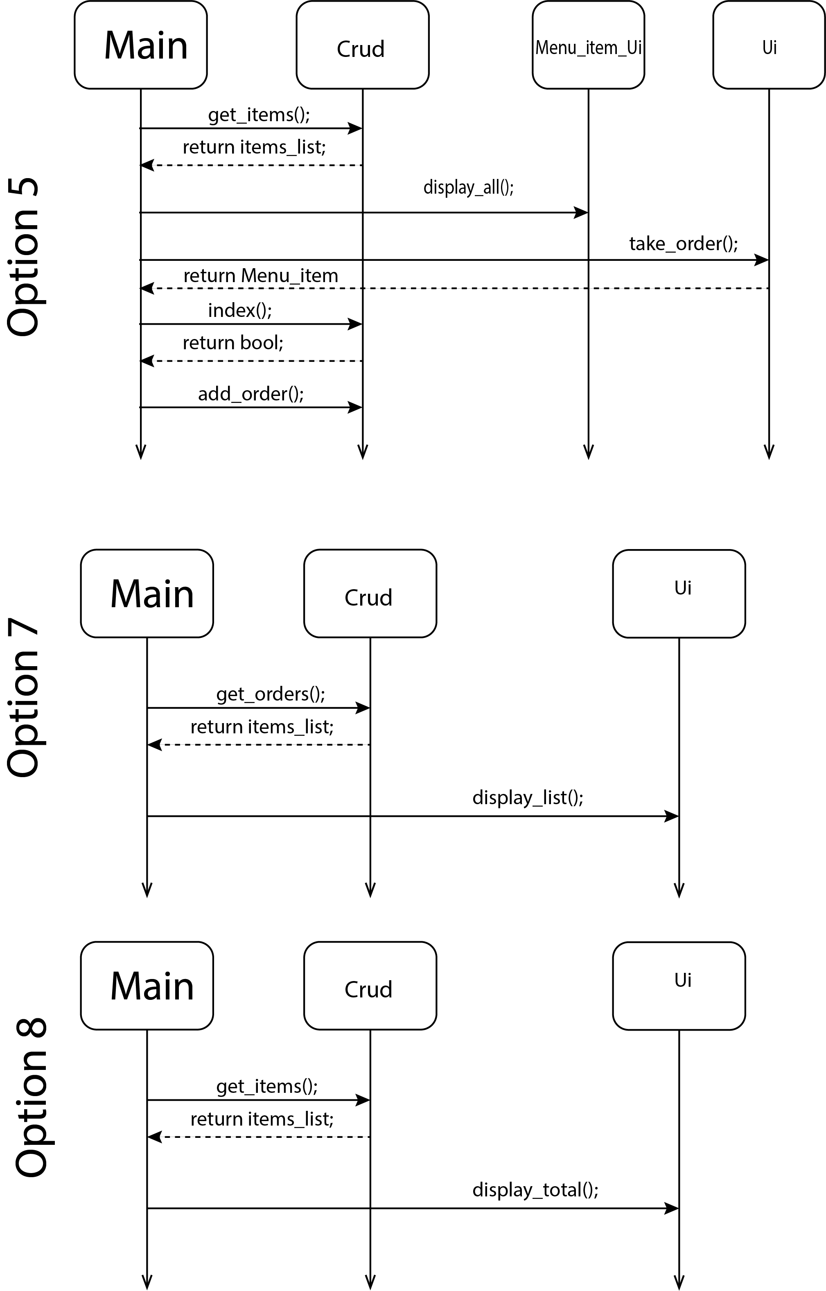

# **GAME OBJECT**

## **Case Study Scenario**

In this problem, you have to create a class called Point, which models a 2D point with x and y

coordinates.

It contains:

● Two instance variables x (int) and y (int).

● A default (or "no-argument" or "no-arg") constructor that constructs a point at the default location

of (0, 0).

● A parameterized constructor that constructs a point with the given x and y coordinates.

● Getter and setter for the instance variables x and y.

● A method setXY() to set both x and y.

Next, create a class named Boundary.

It contains:

● Four attributes of Point type

○ TopLeft

○ TopRight

○ BottomLeft

○ BottomRight

● A default (or "no-argument" or "no-arg") constructor that constructs a boundary with default

location of TopLeft(0, 0), TopRight(0,90), BottomLeft(90,0) and BottomRight(90,90).

● A parameterized constructor that constructs a boundary with the given TopLeft, TopRight,

BottomLeft and BottomRight points.

Next, create a class named GameObject.

It contains 4 attributes:

● One attribute Shape (2D Array char type).

● A StartingPoint (Point type).

● A Premises (Boundary type).

● A Direction (String type).

● A default constructor that initializes

○ Shape (1x3 line “---”)

○ StartingPoint (constructs a point at the default location of (0, 0))

○ Premises (constructs a boundary with default location of TopLeft(0, 0), TopRight(0,90),

BottomLeft(90,0) and BottomRight(90,90))

○ Direction (“LeftToRight”)

● A parameterized constructor that takes

○ Shape, StartingPoint

○ Whereas Premises (constructs a boundary with default location of TopLeft(0, 0),

TopRight(0,90), BottomLeft(90,0) and BottomRight(90,90)) and Direction with default

direction (“LeftToRight”)

● A parameterized constructor that takes

○ Shape

○ StartingPoint

○ Premises

○ Direction

● It will also contain the following methods

○ Move: if the direction is “LeftToRight”, the shape will move one step according to its

direction. For example, if the direction is from left to right it will move the game object

one step toward right.

○ Erase: When called, this method will erase the shape on the console.

○ Draw: When called, this method will draw the shape on the console.

● Following are some examples of the shapes you can draw (Use your creativity to come up with

different shapes)

## **Domain Model with only the Class names**

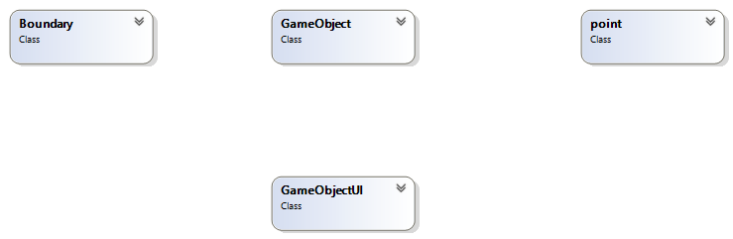

## **Domain Model with Relations and Constraints**

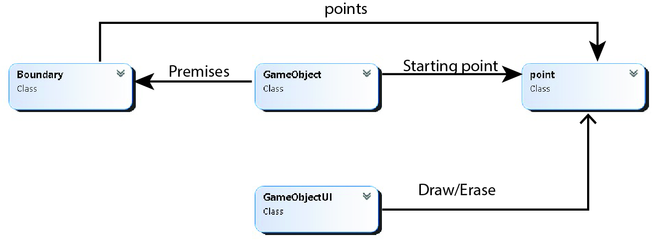

## **Class Diagram**

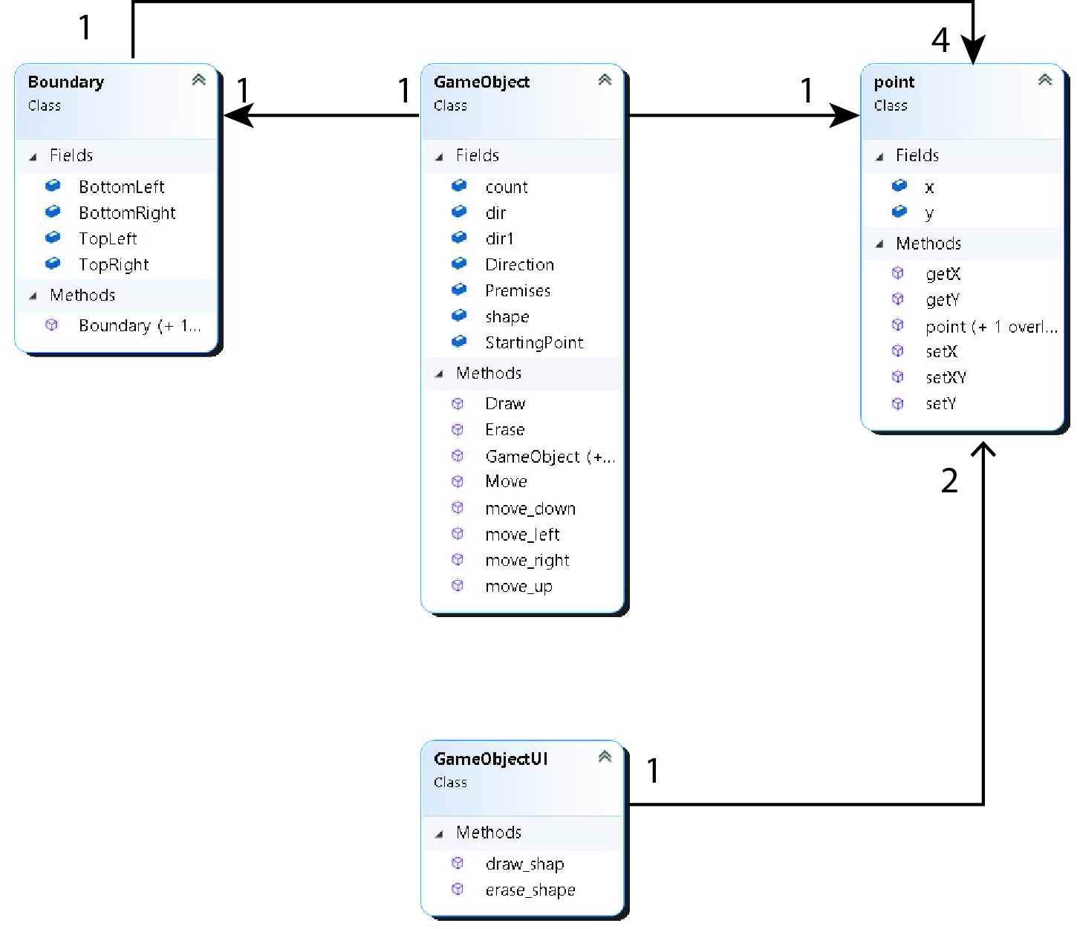

## **Full Code**

class point

{

public int x;

public int y;

public point() { }

public point(int x, int y)

{

this.x = x;

this.y = y;

}

public int getX()

{

return x;

}

public int getY()

{

return y;

}

public void setX(int x)

{

this.x = x;

}

public void setY(int y)

{

this.y = y;

}

public void setXY(int x, int y)

{

this.x = x;

this.y = y;

}

}

class GameObject

{

public char[,] shape;

public point StartingPoint=new point();

public Boundary Premises= new Boundary();

public string Direction;

public bool dir = true;

public bool dir1 = false;

public int count = 0;

public void Erase()

{

Ui.erase_shape(shape,StartingPoint);

}

public void Draw()

{

Ui.draw_shap(shape,StartingPoint);

}

public void Move()

{

if (Direction == "LeftToRight")

{

move_right();

}

else if (Direction == "RightToLeft")

{

move_left();

}

else if (Direction == "Patrol")

{

if(dir)

{

move_right();

}

else

{

move_left();

}

}

else if (Direction == "Diagonal")

{

if (dir)

{

move_right();

}

else

{

move_left();

}

if (dir1)

{

move_up();

}

else

{

move_down();

}

}

else if (Direction == "Projectile")

{

if(count<5)

{

move_up();

move_right();

}

if(count>=5 && count <= 7)

{

move_right();

}

if(count > 7 && count <19)

{

move_down();

move_right();

}

count++;

}

}

public void move_right()

{

if (StartingPoint.getY() != 30)

{

StartingPoint.setY(StartingPoint.getY() + 1);

}

if(StartingPoint.getY()==30)

{

dir = false;

}

}

public void move_left()

{

if (StartingPoint.getY() != 0)

{

StartingPoint.setY(StartingPoint.getY() - 1);

}

if (StartingPoint.getY() == 0)

{

dir = true;

}

}

public void move_down()

{

if (StartingPoint.getX() != 30)

{

StartingPoint.setX(StartingPoint.getX() + 1);

}

if (StartingPoint.getX() == 30)

{

dir1 = true;

}

}

public void move_up()

{

if (StartingPoint.getX() != 0)

{

StartingPoint.setX(StartingPoint.getX() - 1);

}

if (StartingPoint.getX() == 0)

{

dir1 = false;

}

}

public GameObject()

{

//point start = new point();

//Boundary premises = new Boundary();

shape = new char[1, 1] { { '#' } };

StartingPoint = new point(0,0);

//Premises = premises;

Direction = "Diagonal";

}

public GameObject(char[,] shape, point StartingPoint, Boundary Premises, string Direction)

{

this.shape = shape;

this.StartingPoint = StartingPoint;

this.Premises = Premises;

this.Direction = Direction;

}

public GameObject(char[,] shape, point StartingPoint)

{

this.shape = shape;

this.StartingPoint = StartingPoint;

Boundary premises = new Boundary();

Premises = premises;

Direction = "LeftToRight";

}

}

class Boundary

{

public point TopLeft=new point();

public point TopRight = new point();

public point BottomLeft = new point();

public point BottomRight = new point();

public Boundary()

{

TopLeft.x = 0;

TopLeft.y = 0;

TopRight.x = 0;

TopRight.y = 90;

BottomLeft.x = 90;

BottomLeft.y = 0;

BottomRight.x = 90;

BottomRight.y = 90;

}

public Boundary(point TopLeft, point TopRight, point BottomLeft, point BottomRight)

{

this.TopLeft = TopLeft;

this.TopRight = TopRight;

this.BottomLeft = BottomLeft;

this.BottomRight = BottomRight;

}

}

class Ui

{

public static void draw_shap(char[,] shape,point boundary)

{

int m = 0;int n = 0;

for(int i=boundary.getX(); i < (boundary.getX()+ shape.GetLength(0)); i++)

{

n = 0;

for(int j=boundary.getY(); j< (boundary.getY() + shape.GetLength(1)); j++)

{

Console.SetCursorPosition(j, i);

Console.Write(shape[m,n]);

n++;

}

m++;

Console.WriteLine();

}

}

public static void erase_shape(char[,] shape, point boundary)

{

int m = 0; int n = 0;

for (int i = boundary.getX(); i < (boundary.getX() + shape.GetLength(0)); i++)

{

n = 0;

for (int j = boundary.getY(); j < (boundary.getY() + shape.GetLength(1)); j++)

{

Console.SetCursorPosition(j, i);

Console.Write(" ");

n++;

}

m++;

Console.WriteLine();

}

}

}

class Program

{

static void Main(string[] args)

{

GameObject gameObject = new GameObject();

while (true)

{

Thread.Sleep(100);

gameObject.Erase();

gameObject.Move();

gameObject.Draw();

}

}

}

## **Sequence Diagram**

